**ADTA 5240** - **Harvesting, Storing, and Retrieving Data**



**Severe Flooding in Small Villages**

**Nonprofit Organization: Village Resilience Initiative**



**Group 2**

**Team Members:**

Arjun Palaniswamy

Kaushikan Dinakaran

Rohith Singh Thakur

Usha Aavula

Sparsha Dandganhalli Prakash

Anusha Pottipogu

**Table of Contents**

| **S. No.** | **Section Title** | **Page Number** |
| --- | --- | --- |
| 1. | Abstract | 3 |
| 2. | Project Implementation | 4 |
| 3. | Data Generation | 4 |
| 4. | Data Collection | 5 |
| 5. | Data Processing | 6 |
| 6. | Data Storage | 9 |
| 7. | Data Management | 11 |
| 8. | Data Analysis | 12 |
| 9. | Comparison between Hive and Spark Outputs | 26 |
| 10. | BONUS Implementation- Data Visualization and Interpretation | 27 |
| 11. | Meeting Notes | 32 |
| 12. | Data Life Cycle Assignment Table | 37 |
| 13. | Conclusion | 38 |
| 14. | References | 39 |

**Abstract**

As a data engineering team of a nonprofit organization called the Village Resilience Initiative, we created a project that addressed the imperative problem of flooding at the village level. It was a project aimed at positioning the organization so that it could predict, monitor, and respond to occurrences of flooding, leveraging cloud data architecture with analytics. What we utilized were GCP services, namely BigQuery, Hive, and Spark, for querying as well as handling static as well as streaming data.

With the static dataset, we processed patterns of past floods to derive county-level total damage, the five most lethal floods, and per-year event frequencies. With the streaming datasets, we monitored average daily temperatures and highest wind speeds to feed into real-time risk of flooding. We passed through the data lifecycle steps of generation, collection, processing, storage, management, analysis, visualization, and interpretation within the project.

We kept the datasets securely stored within Google Cloud Storage, processed them within Dataproc clusters, cleaned them within Hive and Spark SQL, and examined the results within BigQuery. We visualized the results of the analysis using Looker Studio, presenting trends and risk indicators to stakeholders. The data science team will, going forward, utilize the processed data for building predictive models as well as early-warning dashboards for improvement of the nonprofit’s disaster response.

**Project Implementation**

**Introduction**

Flooding is one of the most destructive natural disaster, especially for rural villages with inadequate infrastructures as well as slow emergency response. Under the aegis of the Village Resilience Initiative, we have been helping to increase the resilience of these vulnerable villages using the power of data. By creating a strong data platform on the Google Cloud Platform (GCP), we wanted to transform raw environmental data as well as historical data into actionable information with the assistance of which we can facilitate faster decision making as well as increased preparedness for floods.

Our work spans the full data process, from the collection of the actual data to its final interpretation according to data life cycle guidelines. Through extensive collection, processing, storage, and data analysis, we transformed huge volumes of data from floods into valuable information that can be utilized for decision making for disaster mitigation. Following sections guide one through each step of data life cycle applied for this project.

1. **Data Generation**

**Static Dataset:** [NOAA Storm Events Database - Texas](https://www.ncdc.noaa.gov/stormevents/choosedates.jsp?statefips=48%2CTEXAS)

We chose to work with this static dataset because it provides a vast history of floods that have occurred in Texas with data ranging from damage to property, loss of life, to date of occurrence. This dataset is up to 2024, so we have extremely recent data which makes our project even more valid and practical. With so much quality data for history, we can identify long-term trends, determine areas of high risk, and have a full idea of scope and size of changes of flooding over time. Having recent records means we can predict with even greater accuracy and are able to provide even more specific recommendations for disaster preparedness and risk reduction measures to follow.

**Dynamic Data source:** [OpenWeatherMap Weather Data](https://openweathermap.org)

We chose this dynamic data source because it gives real-time as well as historical weather readings of wind speed, rainfall, and temperature at a comparatively lesser cost compared with other business weather APIs. Its affordability along with worldwide coverage provided a cost-effective as well as scalable solution for continuous monitoring of environmental conditions that affect flood risk.

**Additional Dynamic Dataset (Elevation Data):** [Open-Elevation API](https://open-elevation.com/)

We have also added elevation data to the project through the Open-Elevation API. This was a significant consideration because we are looking at the likelihood of flooding: lower ground is more likely to be overwhelmed with flooding from rainfall. Using elevation data, we were able to add more precision to the project as well as offering higher precision for determining most disaster-level flooding areas.

1. **Data Collection**

**Static Data:**

We obtained our primary static dataset from NOAA Storm Events Database. The study examined Texas-specific flood events throughout the time period starting from January 1, 2010 and ending in 2024. Through the NOAA query interface we performed an exact selection of "Flood" for the event type and a specification of Texas state FIPS code 48 while setting distinct start and end dates for yearly parameters. We extracted annual records from the NOAA platform one-by-one due to its 500 records per download restriction and subsequently merged the acquired data sets. We obtained 5,079 flood event records throughout our research. The database containing static data revealed important historical details about flood patterns together with event severity and the affected regions in Texas.

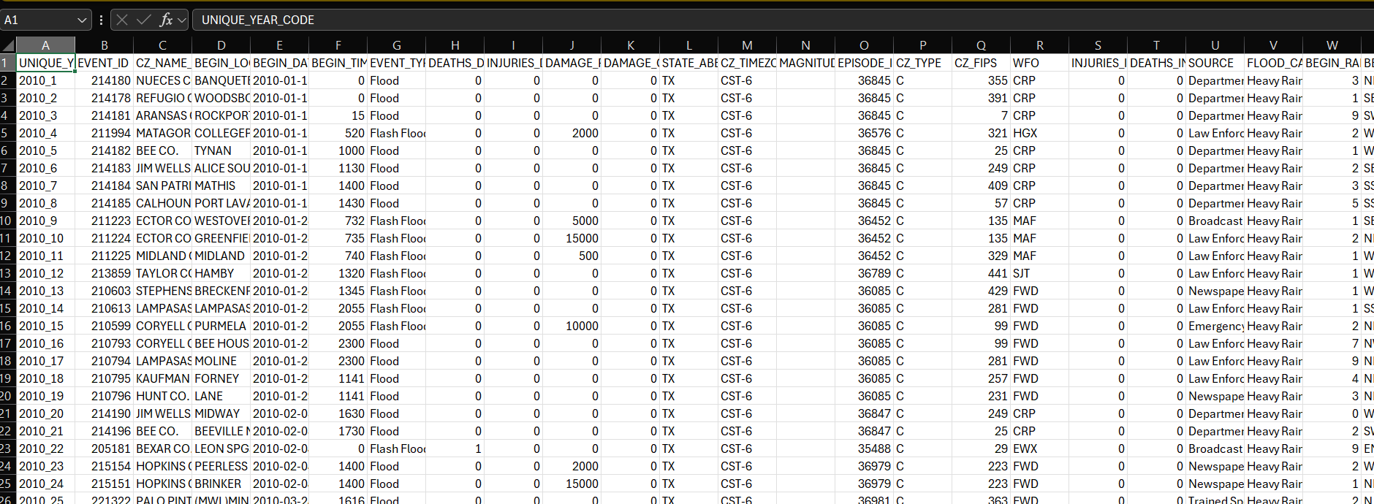

**Screenshot:** Static Dataset Overview (Kaushik)

**Dynamic data:**

The static dataset required supplementary information by integrating multiple dynamic data sources.

* The OpenWeatherMap API obtained temperature and precipitation levels and wind speed and snow depth features for each event through its geographical coordinates and timeline. The weather data provided critical information about the natural environment related to each flood incident.
* The Open-Elevation API supplied elevation data for all event locations for including their impact on flood vulnerability calculations. The risk of flooding corresponds directly with reduced elevation levels.

The development of Python workflows with precise scripts enabled API request automation, rate limit management, and data extension for each event entry through ID, date, latitude, longitude, timestamp, temp, feels_like, humidity, pressure, wind_speed, wind_deg, wind_gust, clouds_all, rain_1h, snow_1h, elevation, and errors attributes.

We supplemented the static dataset by including dynamic data sources by way of the OpenWeatherMap and the Open-Elevation APIs. We utilized the latitude and longitude coordinates of the static dataset to make calls against the APIs to fetch weather conditions like rainfall and temperature, as well as elevation. This enrichment provided a means of integrating more environment context-based information into the initial set of flood records, making it simpler to assess flood risk through weather status as well as terrain elevation. Therefore, the dynamic enrichment enabled our static flood records to receive environmental data, thus boosting their usefulness for predictive analysis and modeling purposes.

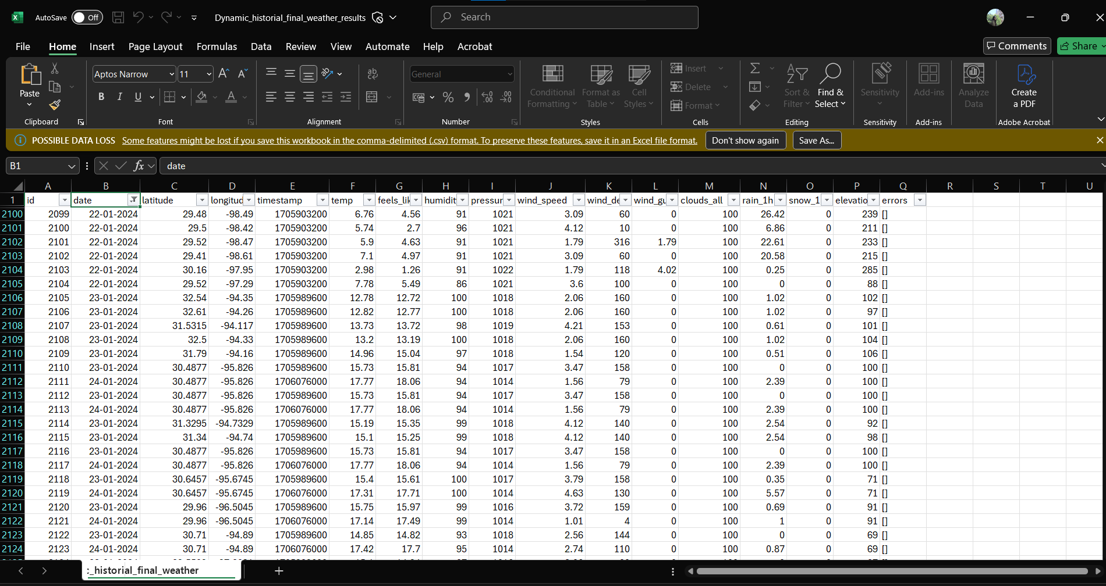

**Screenshot:** Dynamically retrieved weather and elevation data using matching date, longitude, and latitude from the static data set, enhancing the original flood records for further analysis. *(Screenshot by Sparsha)*

1. **Data Processing**

We combined all yearly static datasets into a unified project using OpenRefine after obtaining them through its consistent column formats. We discovered multiple columns with mostly empty values during the clean-up process in TOR_WIDTH, TOR_LENGTH, and MAGNITUDE since these fields did not support flood investigation. The maintained data process included a systematic removal of these columns for better dataset control.

We established UNIQUE_YEAR_CODE after cleanup as a derived column by merging year data with absolute_rownumber numbers to make each flood entry distinct.

A Python script followed its development to perform the following operations:

* The static dataset provided unique data sets comprising latitude, longitude, and date entries.
* The script retrieves elevation and weather data dynamically from OpenWeatherMap and Open-Elevation APIs.
* The script stores all API retrieval failures in the newly added errors field to facilitate examination and maintenance.
* The data enrichment process stores a clean version of the dataset while preserving all initial dataset contents during the dynamic augmentation operations.

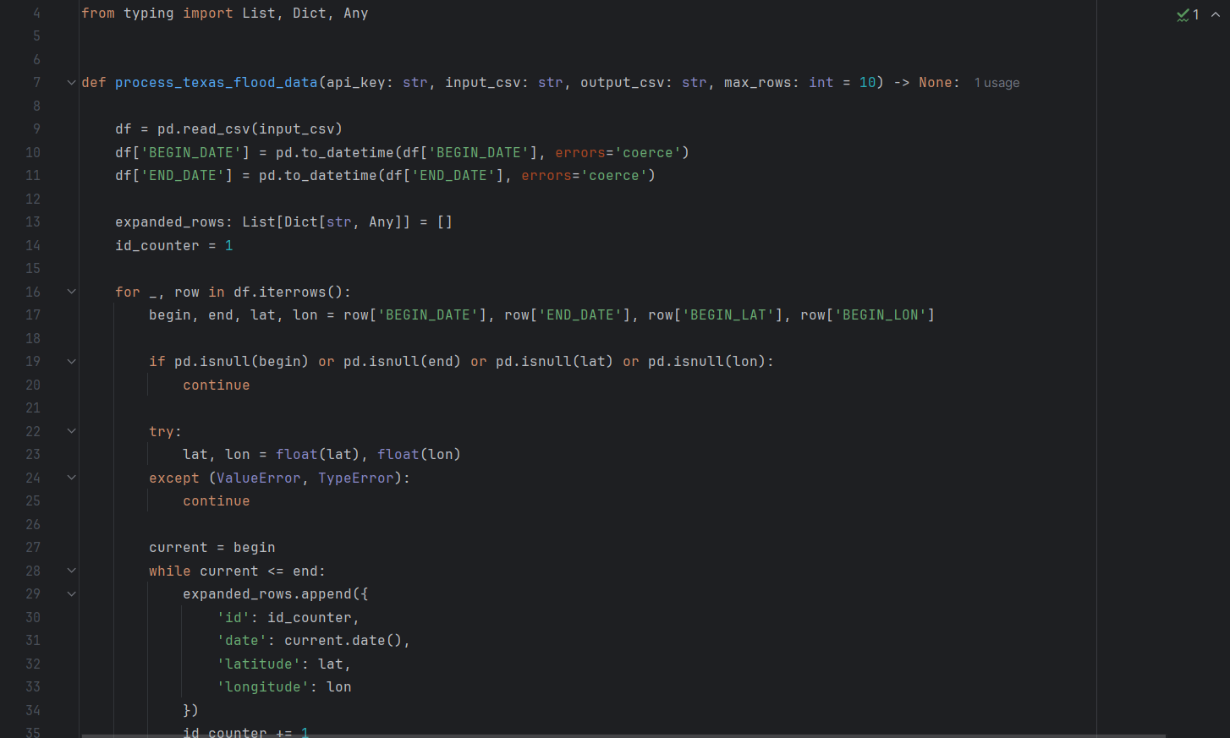

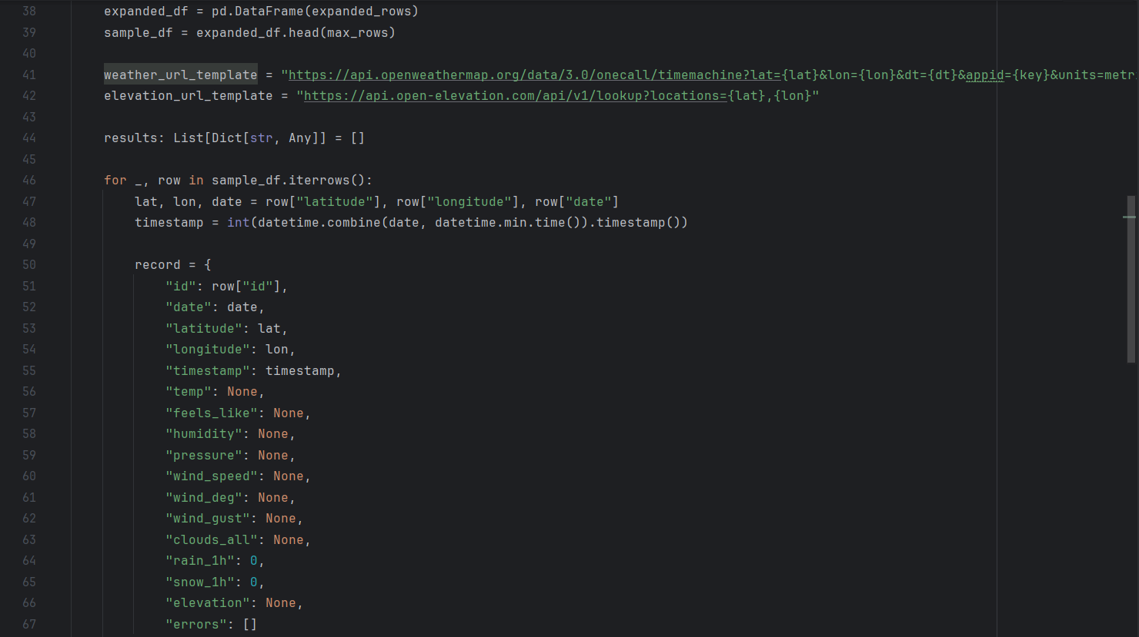

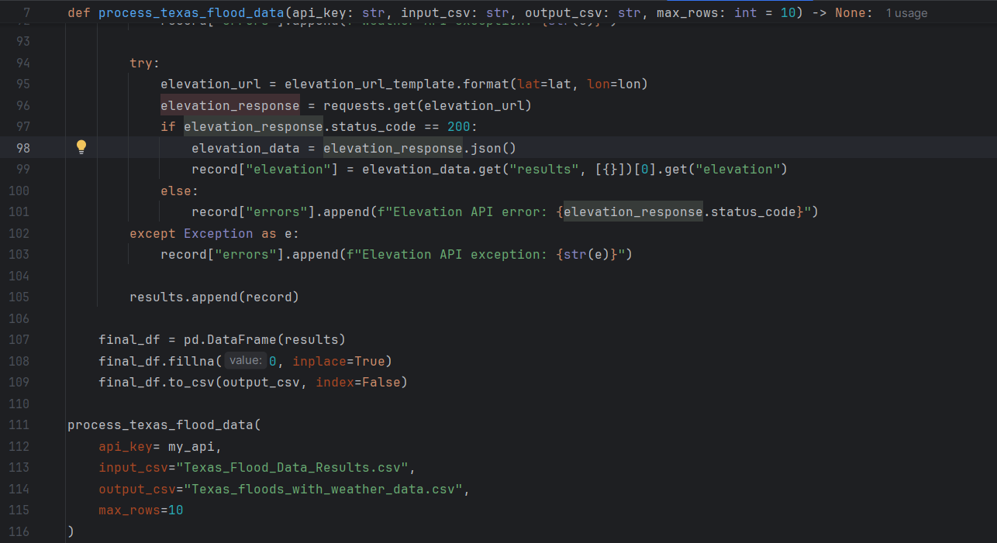

To proceed with additional transformations, the enrichment process required completion.

* The remove of absolute_rownumber column from the dataset served to maintain data clarity.
* The converted BEGIN_DATE and END_DATE fields into SQL and analytical framework compatible date formats.

Organized processes transformed the dataset into a ready state suitable for cloud service analysis and storage needs after data cleaning and normalization and value augmentation.

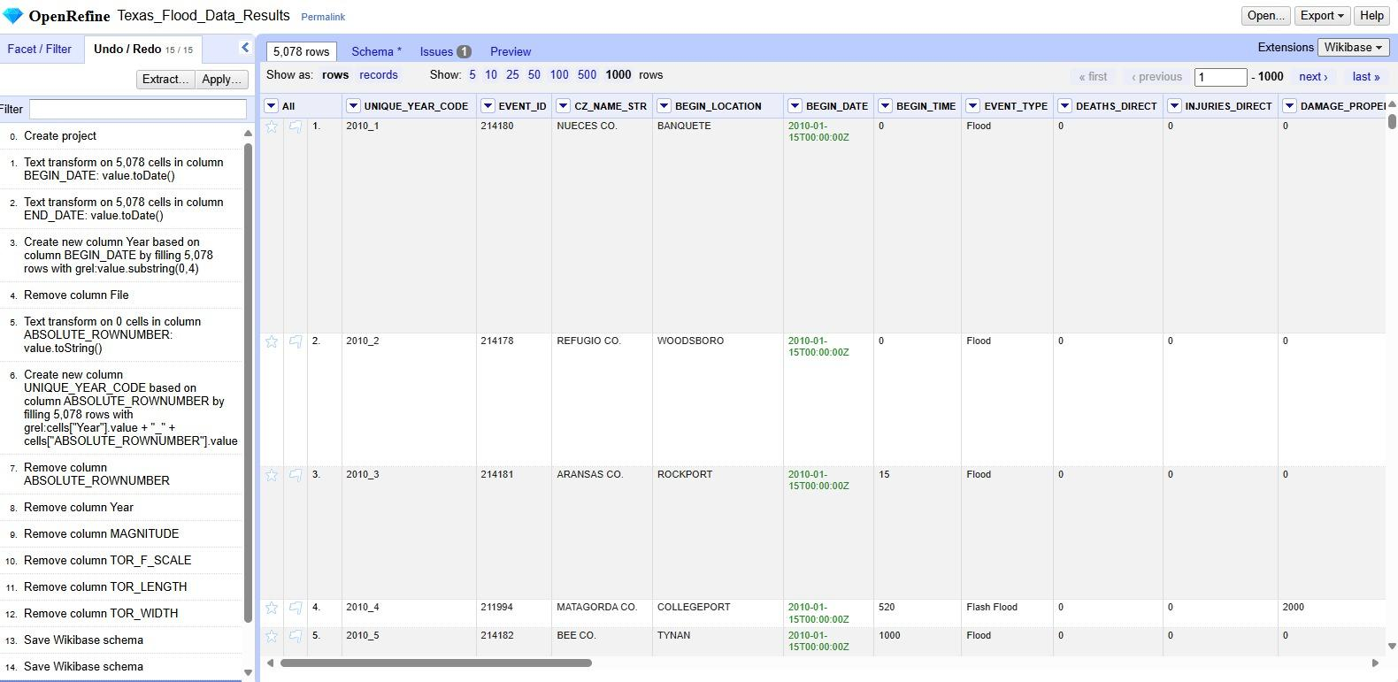

**Screenshot:** Static Dataset cleaning in OpenRefine (Arjun)

1. **Data Storage**

We created a new Google Cloud Platform (GCP) project called *Flood Analysis and Management* at the beginning of the project where all the datasets, the processing tasks, and the resources would be housed in one central location. Multiple Google Cloud Storage (GCS) buckets were created under the project for effective storage of the dynamic and static datasets.The buckets were created for the storage of the NOAA flood data, dynamic weather data of OpenWeatherMap, and the Open-Elevation data, segregating the different sources of the data. Temporary and staging buckets were also created on auto-start of the Dataproc cluster for streamlined Hive and Spark operations. The structured storage configuration provided a secure and structured foundation of the next stages of the data process and analytics process.

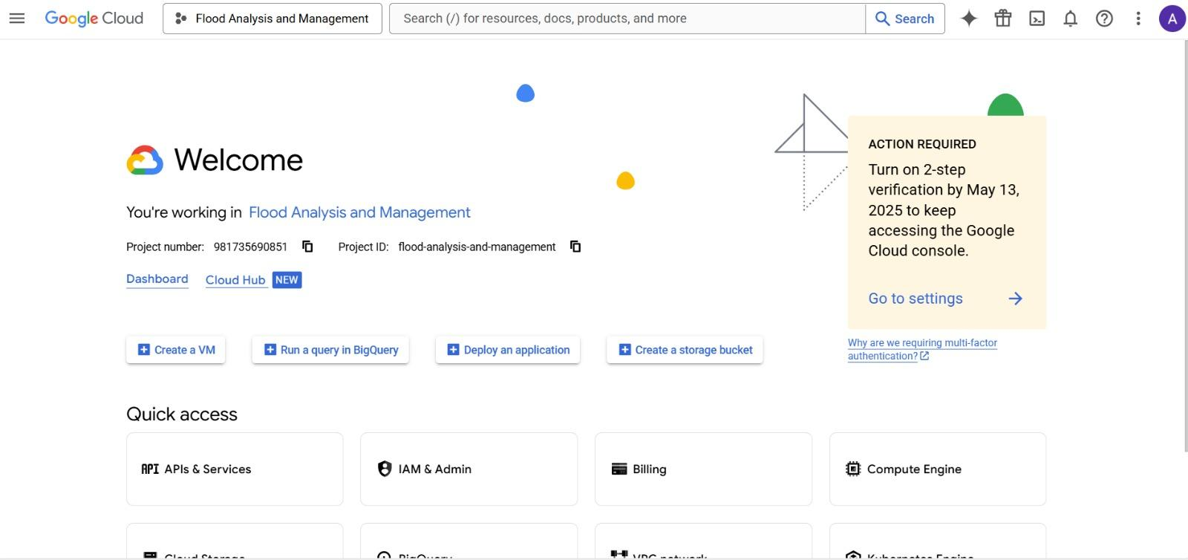

**Screenshot:** Created a Project in Google Console (Arjun)

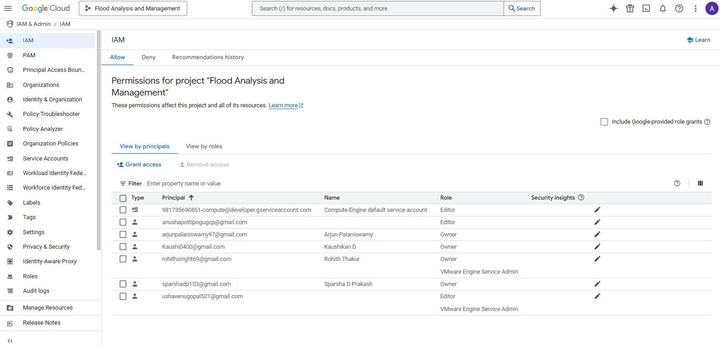

**Screenshot:** Provided access to all users (Arjun)

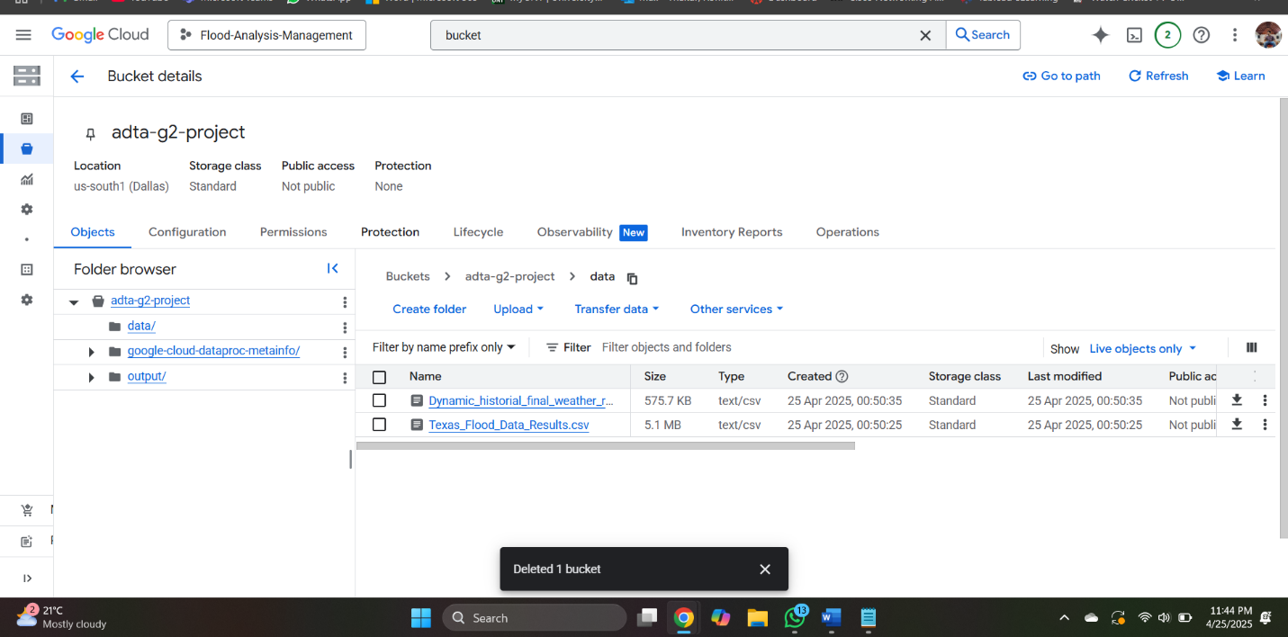

**Screenshot:** Created a bucket in Google Console (Arjun)

1. **Data Management**

At the data management level, we had a dedicated GCP project for centralized project and cloud resource data management. Cleaned static data (NOAA flood incidents) as well as dynamic data (open weather & elevation) were loaded into GCS buckets with a clean folder structure for the purpose of usability. The systematic querying and examination were facilitated through the utilization of BigQuery tables while Hive tables were created for regular querying within a shared setup through the utilization of Dataproc clusters. Dataset naming conventions as well as folder hierarchy were set up for team usability. Access was strictly controlled for data protection as well as data integrity of the datasets. We checked data at upload by sampling of records from each dataset to ascertain completeness as well as correctness prior to performing processing as well as analysis.

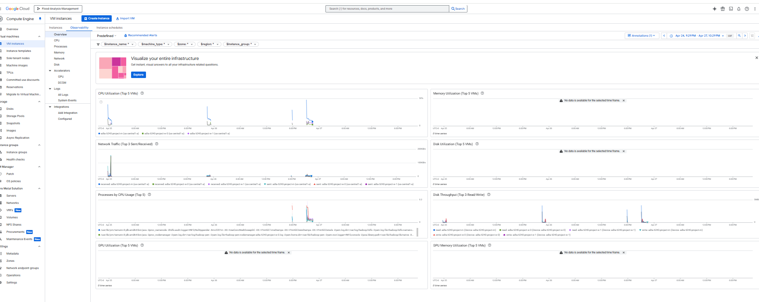

Screenshot: Observability (Arjun)

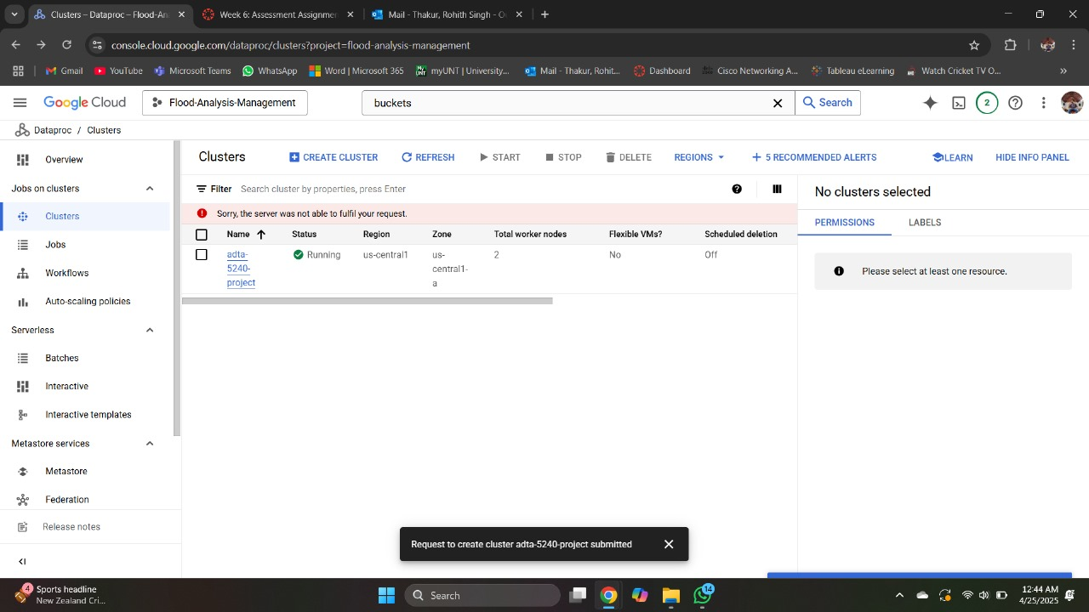

**Screenshot:** Created Cluster (Anusha)

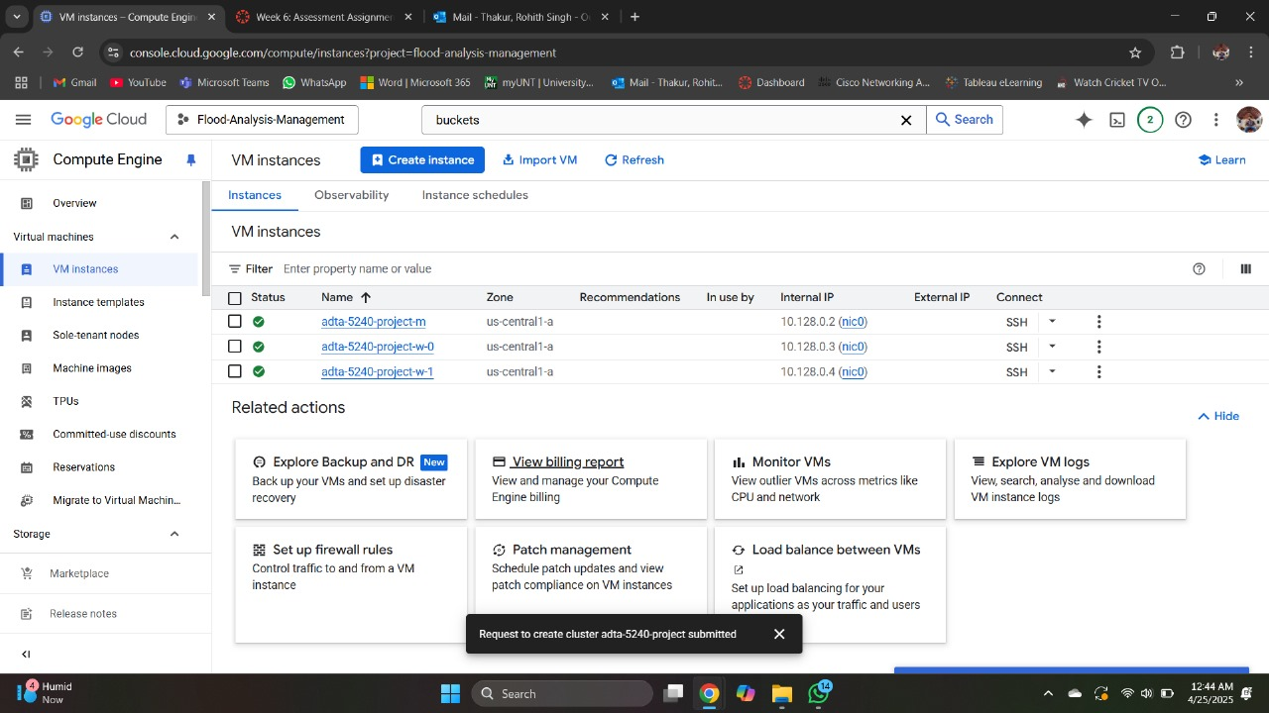

1. **Data Analysis**

During the project analysis phase, we utilized a combination of BigQuery, Hive, and Spark for processing as well as insights from dynamic and static data. On BigQuery, we processed static records of floods for determining total damage for each county, the deadliest floods, as well as tracking the occurrence of events year by year. On dynamic data, we processed daily average temperatures and peak wind speeds for real-time computation of risk of flooding.

Parallel to that, we conducted the same test with Hive and Spark to validate results using other big data frameworks. We were able to query bigger data with a similar SQL-like query structure using Hive, while we could have faster, distributed computing using Spark, especially for handling the dynamic streaming data. Having diverse, unique tools at our disposal provided us with flexibility, scalability, as well as precision within data analytics pipelines.

The multi-platform approach helped us to derive complete conclusions from the real-time as well as historic flood data, thereby improving our ability to provide actionable recommendations for mitigating risks from recurring floods for small villages.

**BIG QUERY: QUERIES for Static Data**

**QUERY 1:**

SELECT CZ_NAME_STR AS County, SUM(DAMAGE_PROPERTY_NUM) AS Total_Property_Damage

FROM `flood-analysis-management.static.TexasFloodAnalysis`

GROUP BY CZ_NAME_STR

ORDER BY Total_Property_Damage DESC;

We used BigQuery to compute flood-related property damages in each county in Texas. We were able to determine areas that were economically impacted by this, as well as areas where more flood resistance was required.

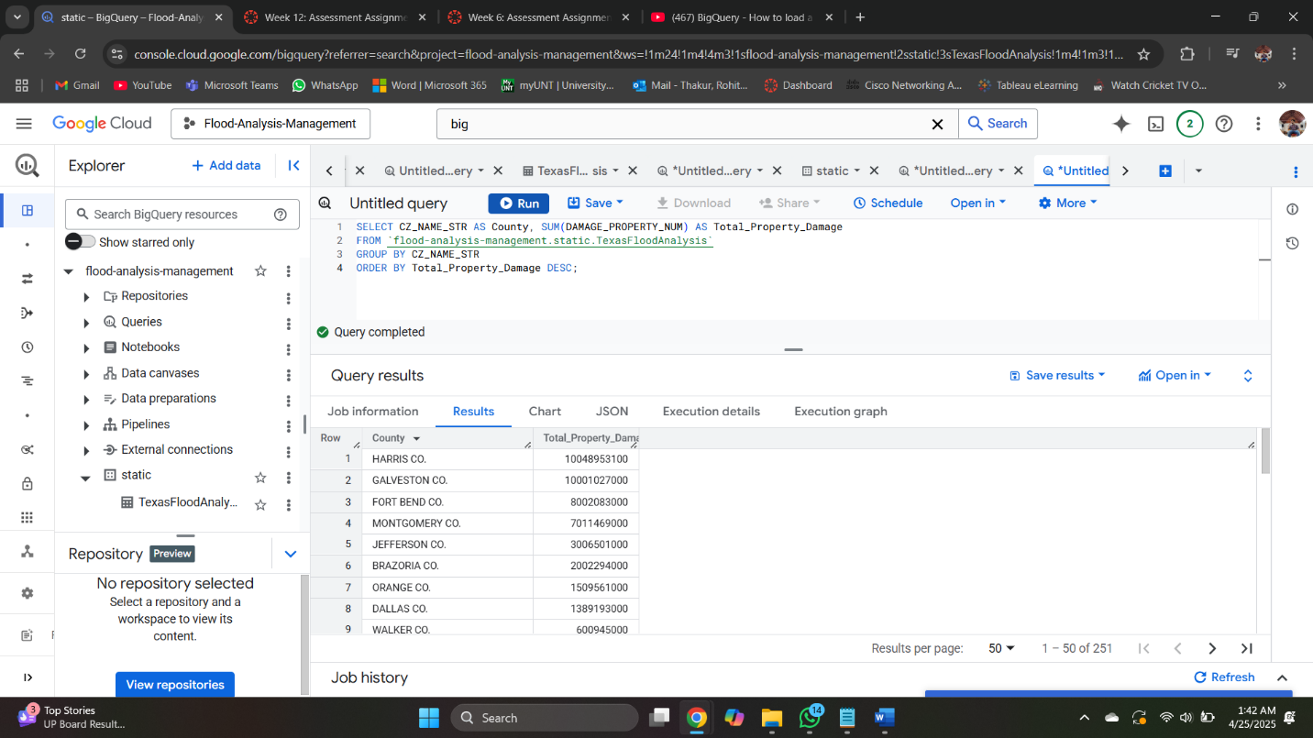

**Screenshot: BigQuery Output: Aggregating Total Property Damage by County in Texas Flood Data (Rohith Singh Thakur)**

**QUERY 2:**

SELECT EVENT_ID, EVENT_TYPE, CZ_NAME_STR, BEGIN_DATE, DEATHS_DIRECT

FROM `flood-analysis-management.static.TexasFloodAnalysis`

ORDER BY DEATHS_DIRECT DESC

LIMIT 5;

The above BigQuery query provided the top five floods resulting in a high number of direct fatalities in Texas. It gives a summary of the deadliest recent flood events, which are useful to make emergency preparation choices.

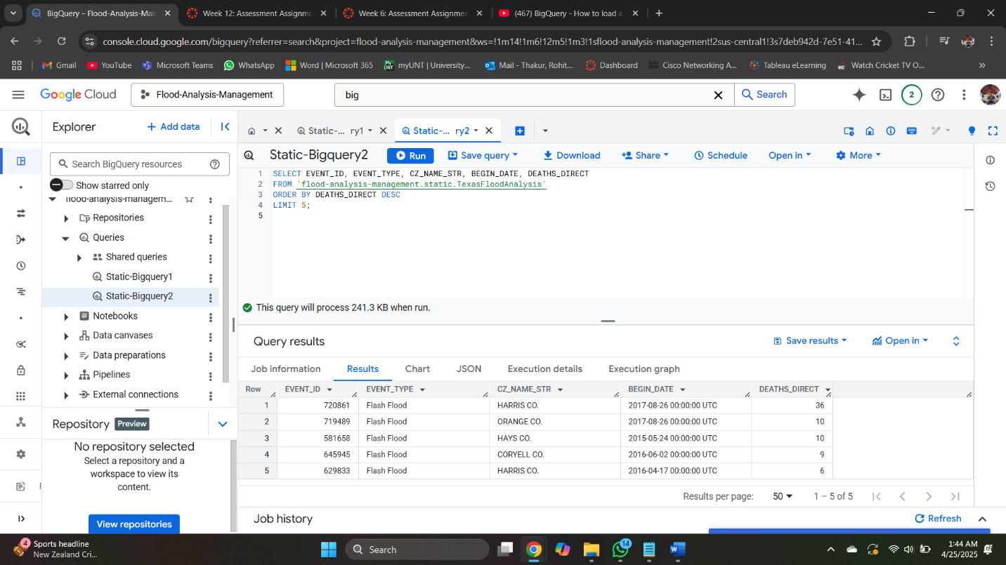

**Screenshot: BigQuery Output: Top 5 Deadliest Flood Events in Texas by Direct Fatalities (Rohith Singh Thakur)**

**QUERY 3:**

SELECT SUBSTRING(UNIQUE_YEAR_CODE, 1, 4) AS Year, COUNT(*) AS Event_Count

FROM `flood-analysis-management.static.TexasFloodAnalysis`

GROUP BY Year

ORDER BY Year;

We used BigQuery to select the count of flood events reported yearly in Texas from 2010 up to 2024. Trend analysis assists us in determining the peak flood years and analyze if flood events are on the rise with time.

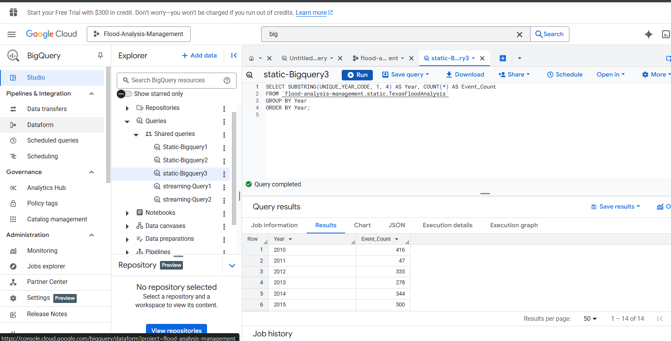

**Screenshot: BigQuery Output: Flood Event Count by Year (Usha Aavula)**

**BIG QUERY (STREAMING DATASET)**

**QUERY 1:**

SELECT date, AVG(temp) AS avg_temperature

FROM `flood-analysis-management.streaming.DynamicHistorical`

GROUP BY date

ORDER BY date;

BigQuery was utilized in computing average daily temperature from live weather data. Tracking temperature patterns assists in monitoring environmental factors that heighten flood risk.

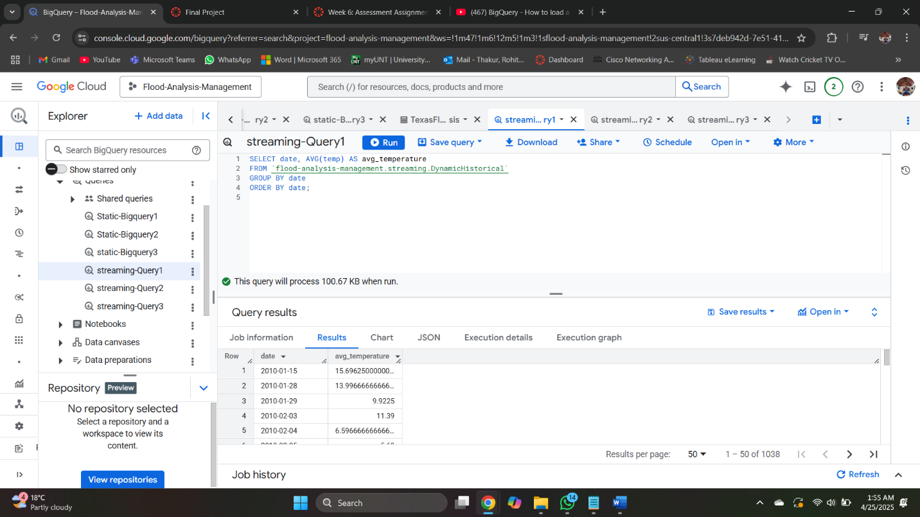

**Screenshot: BigQuery Output: Daily Average Temperature Trends from Dynamic Weather Data (Rohith Singh Thakur)**

**QUERY 2:**

SELECT latitude, longitude, MAX(wind_speed) AS max_wind_speed

FROM `flood-analysis-management.streaming.DynamicHistorical`

GROUP BY latitude, longitude

ORDER BY max_wind_speed DESC

LIMIT 5;

With BigQuery, we sorted the top 5 locations (latitude and longitude) in Texas by the wind speed recorded. This is useful for identification of locations with high wind exposure, which rack up flood damages while storms occur.

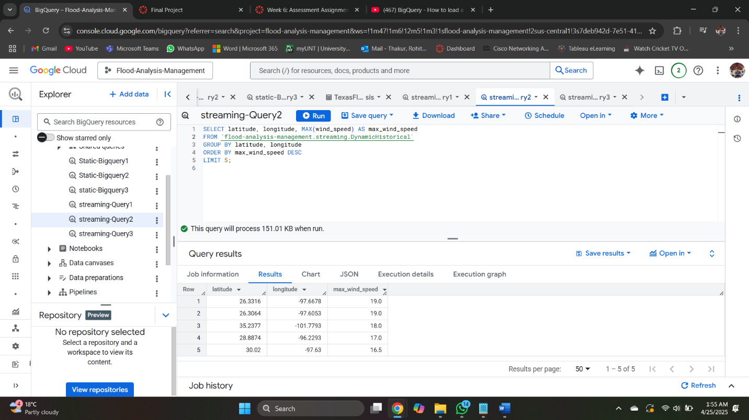

**Screenshot: BigQuery Output: Highest Wind Speeds by Geographic Location (Usha Aavula)**

**DISPLAYING DATASETS (STATIC & STREAMING) IN CLOUD STORAGE**

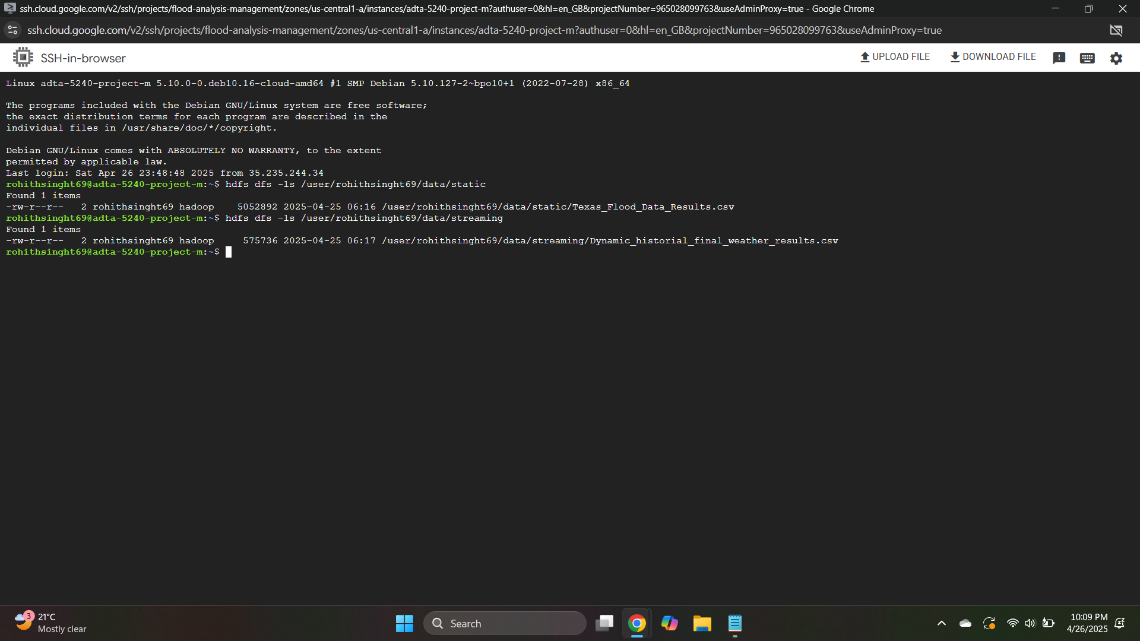

**Screenshot owner: Rohith Singh Thakur**

The same queries were repeated on Hive and Spark environments to produce a comparison of query execution performance.

**HIVE AND SPARK IMPLEMENTATION**

Table Names for HIVE AND SPARK

STATIC: Texas_Flood

STREAMING: Dynamic

**HIVE and SPARK QUERIES (STATIC DATA)**

**HIVE Query Outputs**

**QUERY 1:**

SELECT CZ_NAME_STR AS County, SUM(DAMAGE_PROPERTY_NUM) AS Total_Property_Damage

FROM Texas_Flood

GROUP BY CZ_NAME_STR

ORDER BY Total_Property_Damage DESC;

**Query 1 : 32.525s**

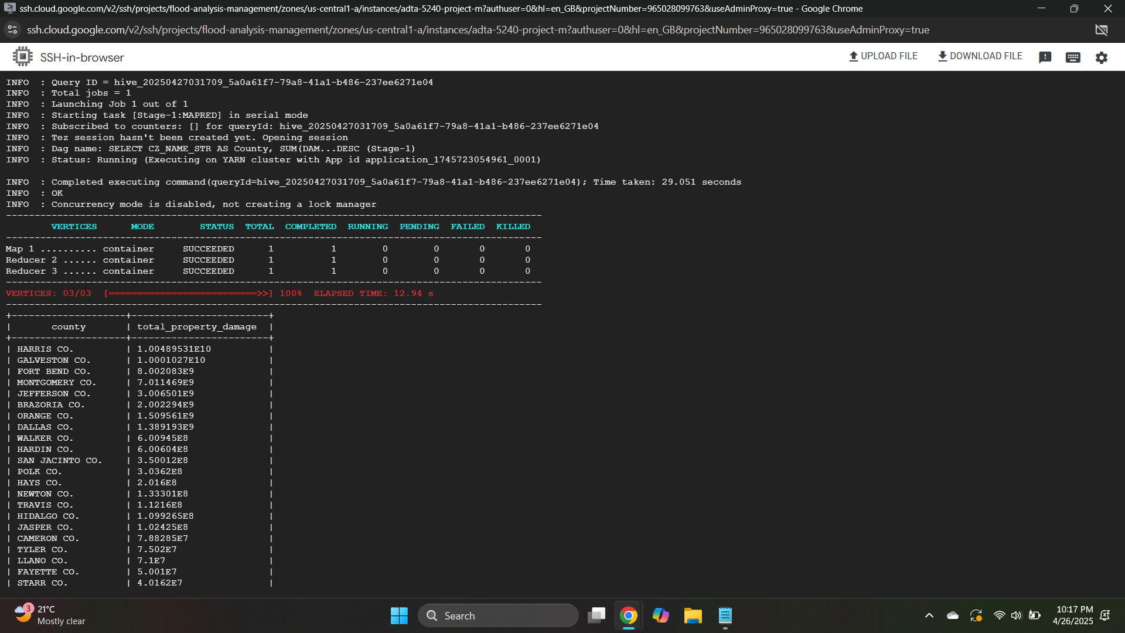

**Screenshot: Hive Query Output: Total Property Damage by County (Static Dataset) (Usha Aavula)**

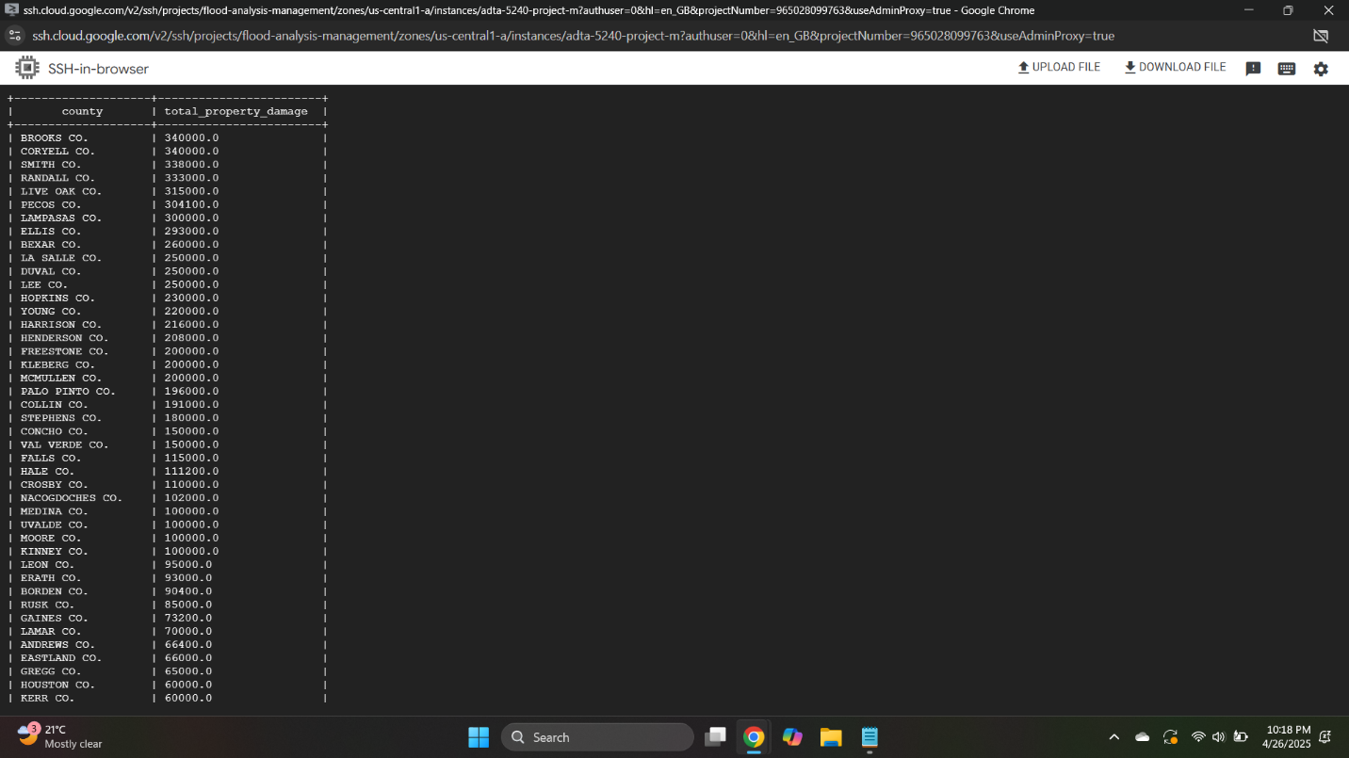

**Screenshot owner: Usha Aavula**

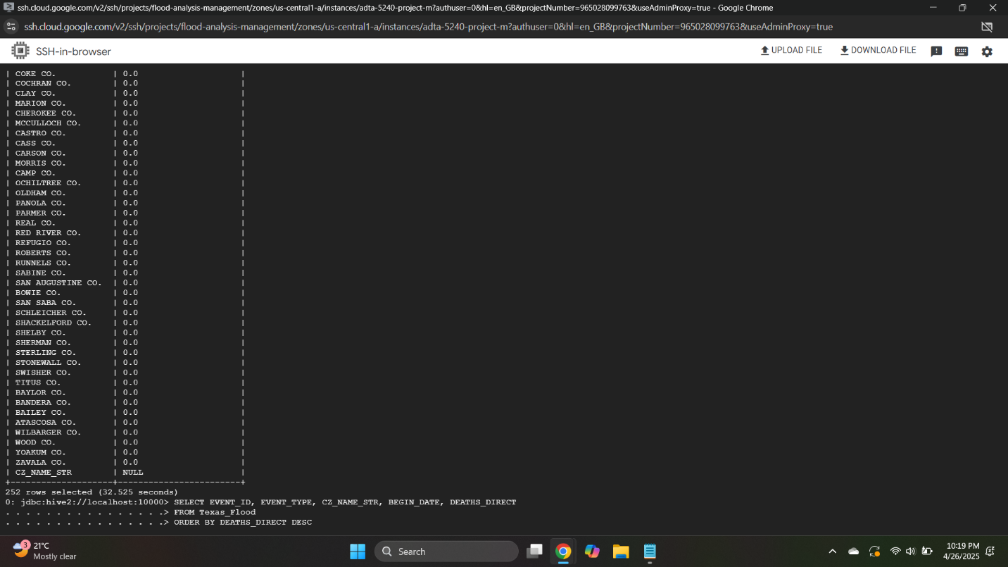

**Screenshot owner: Usha Aavula**

**QUERY 2:**

SELECT EVENT_ID, EVENT_TYPE, CZ_NAME_STR, BEGIN_DATE, DEATHS_DIRECT

FROM Texas_Flood

ORDER BY DEATHS_DIRECT DESC

LIMIT 5;

**Query 2: 7.285s**

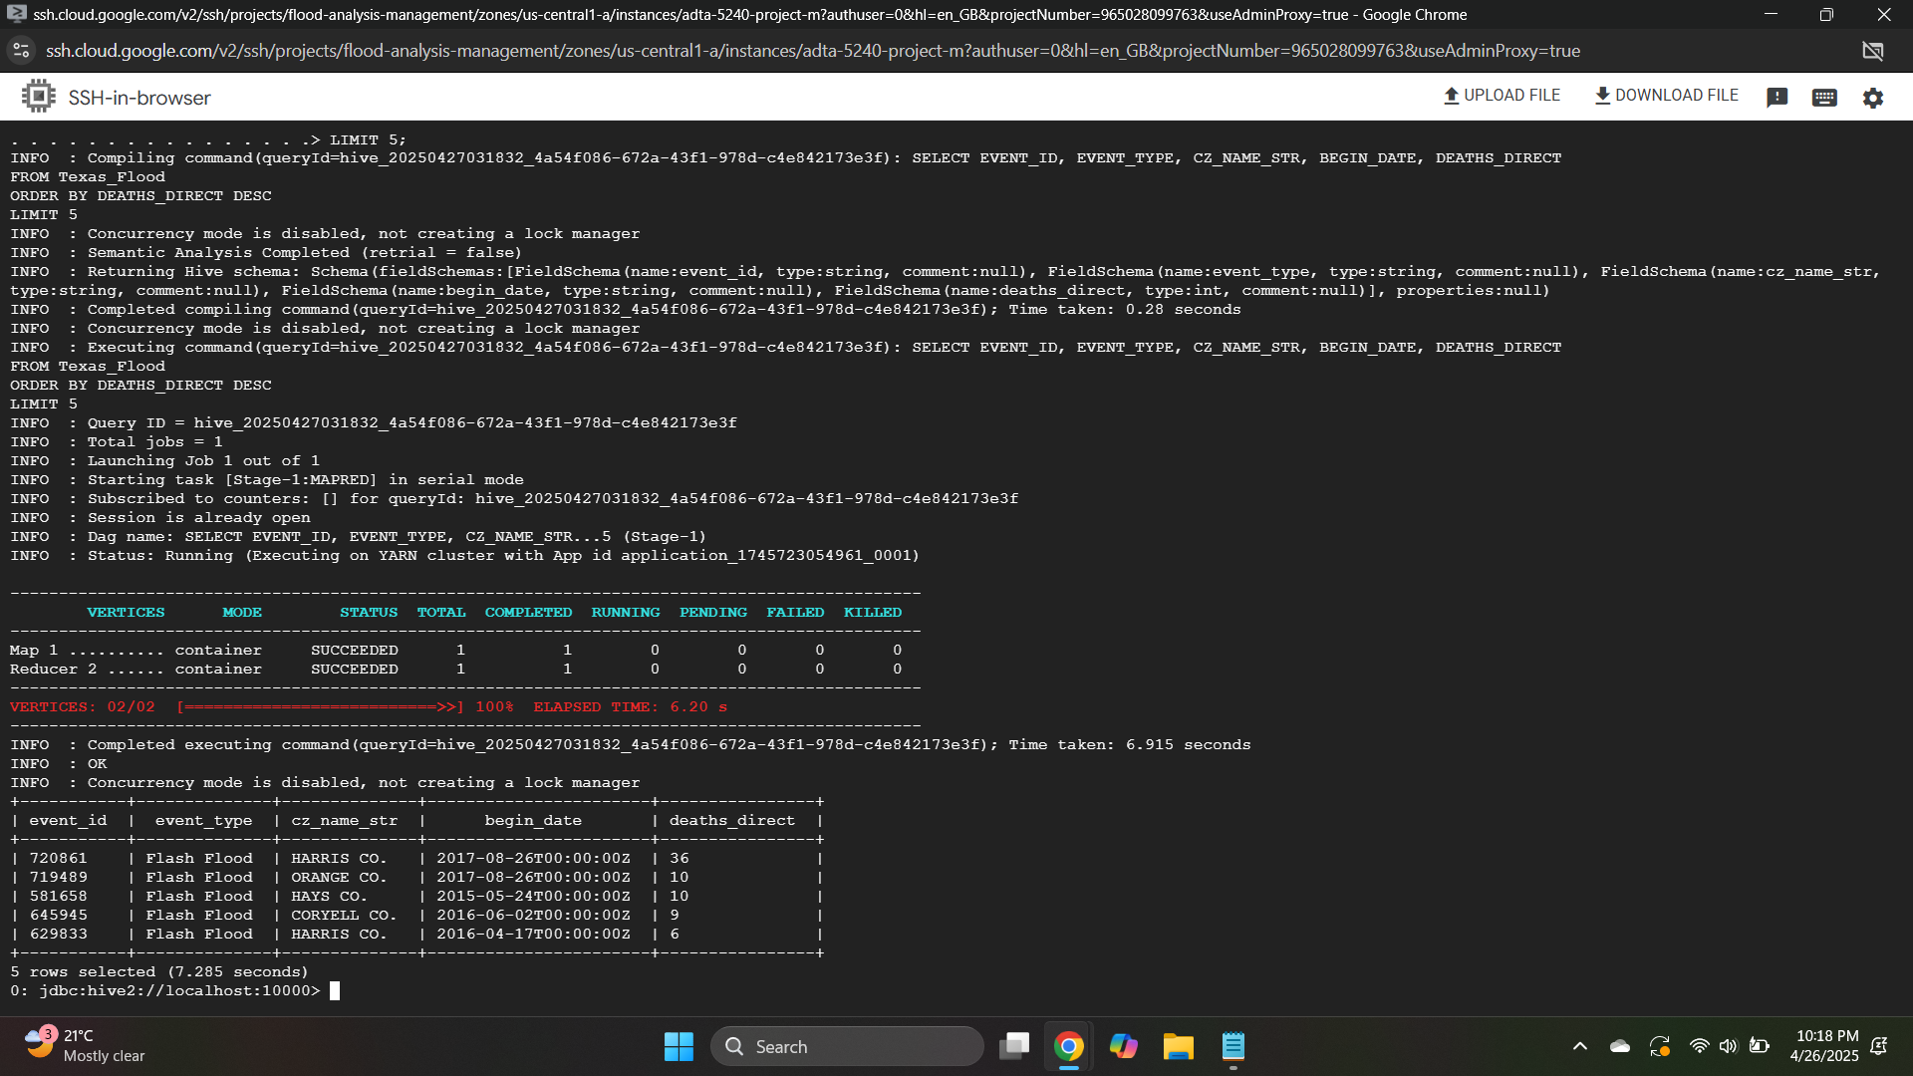

**Screenshot: Hive Query Output: Top 5 Deadliest Flood Events in Texas (Rohith Singh Thakur)**

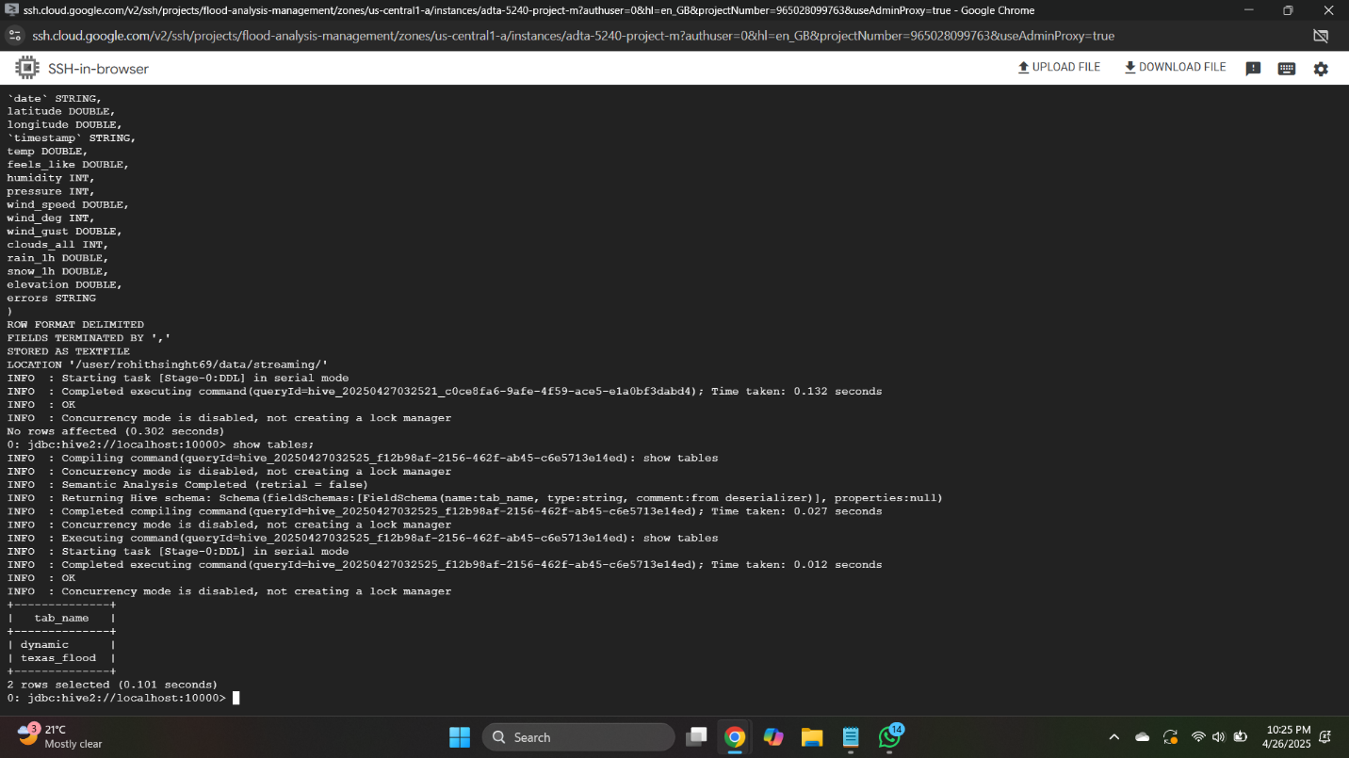

**Screenshot owner: Rohith Singh Thakur**

**SPARK Query Outputs**

**Query 1: 11.302s**

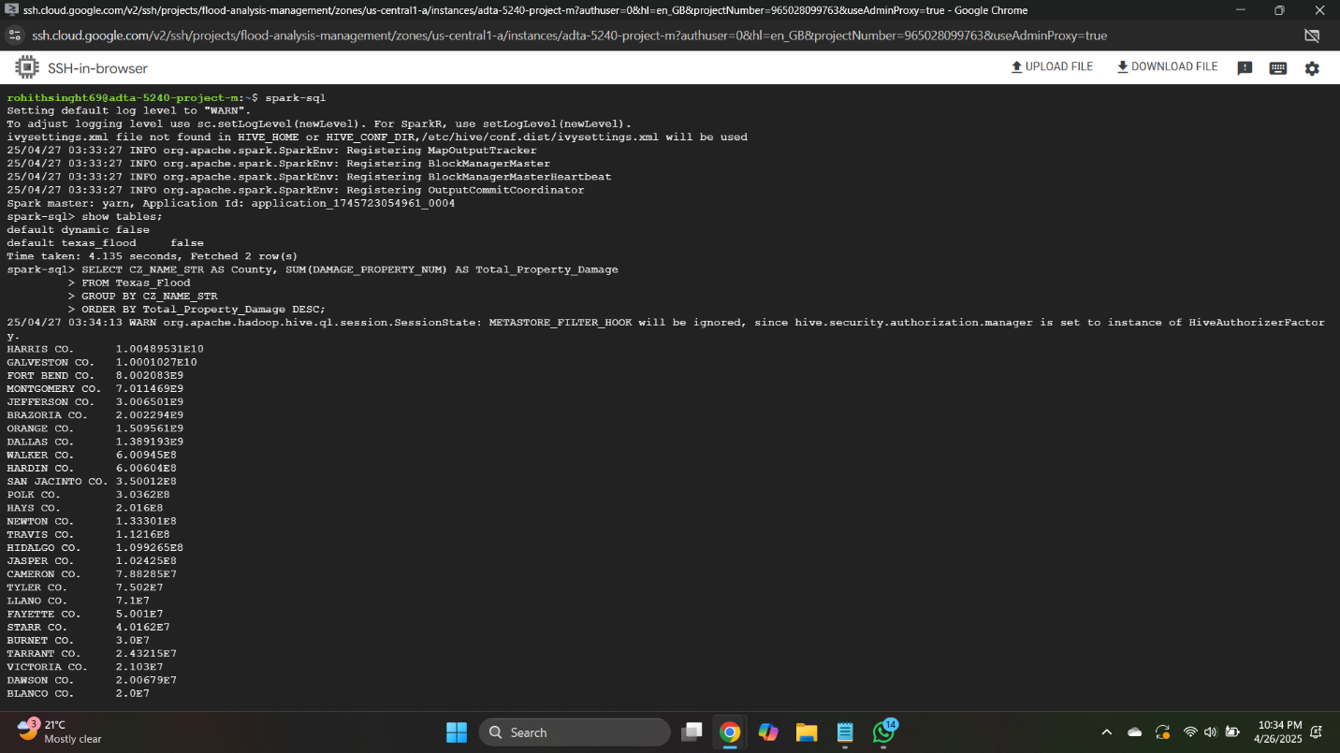

**Screenshot: Aggregating Total Property Damage by County in Texas Flood Data (Spark Output for Static Data) (Usha Aavula)**

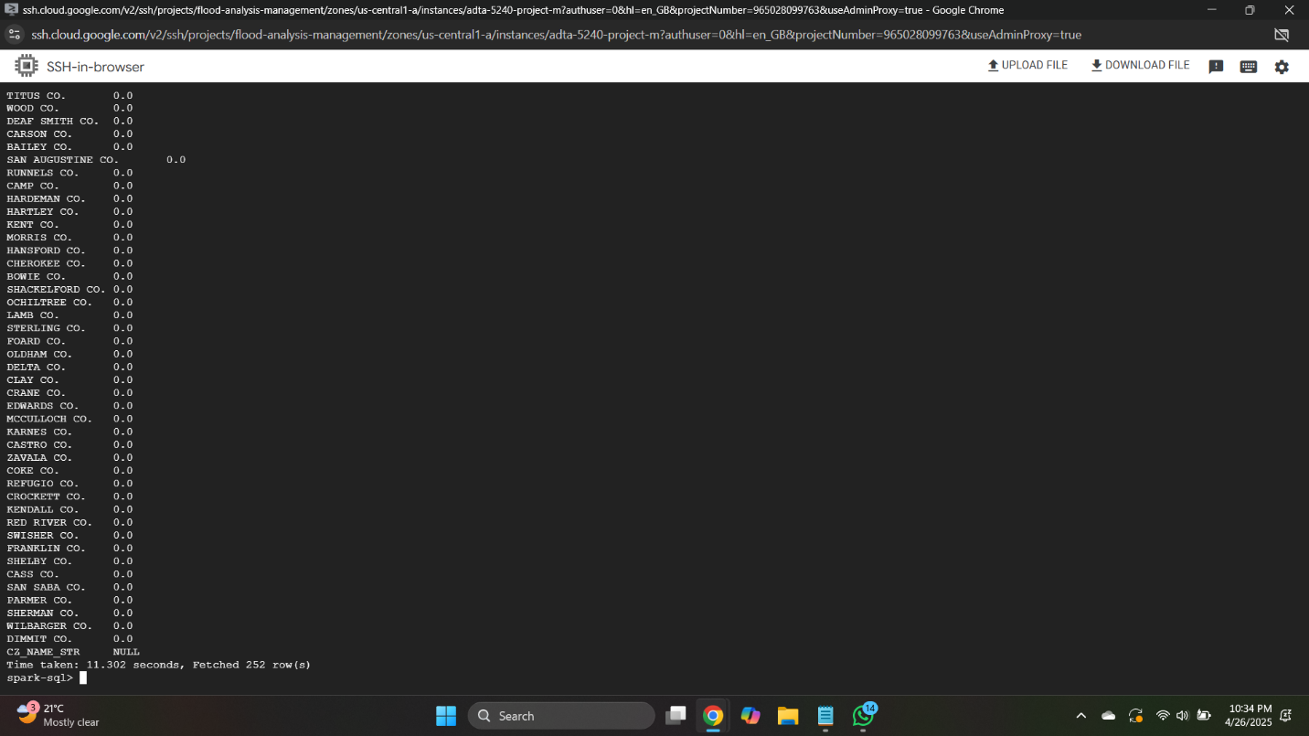

**Screenshot owner: Usha Aavula**

**Query 2: 1.113s**

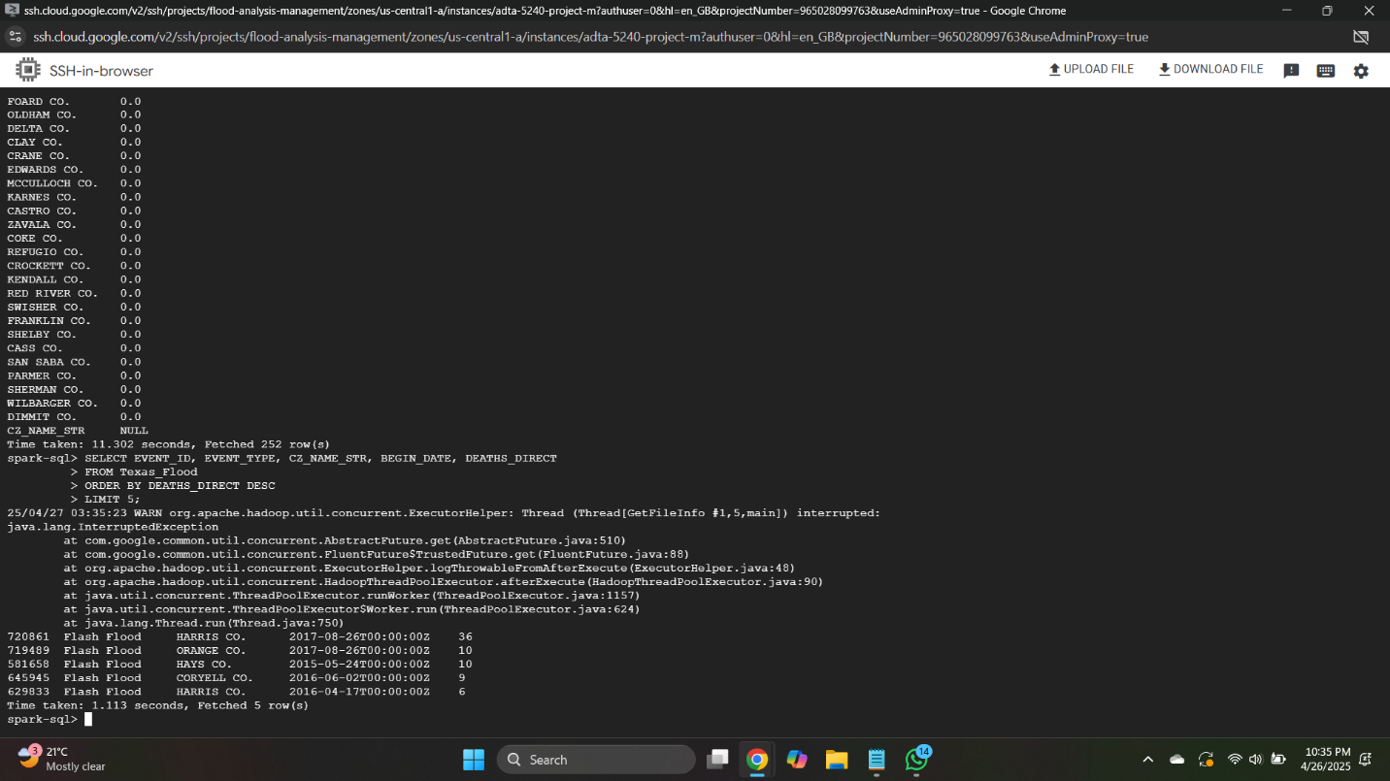

**Screenshot owner: Spark Output- Top 5 Deadliest Flood Events in Texas (Static Data)- Rohith Singh Thakur**

**HIVE and SPARK QUERIES (STREAMING DATASET)**

**HIVE Query Outputs**

**QUERY 1**

SELECT latitude, longitude, MAX(wind_speed) AS max_wind_speed

FROM Dynamic

GROUP BY latitude, longitude

ORDER BY max_wind_speed DESC

LIMIT 5;

**Query 1: 15.445s**

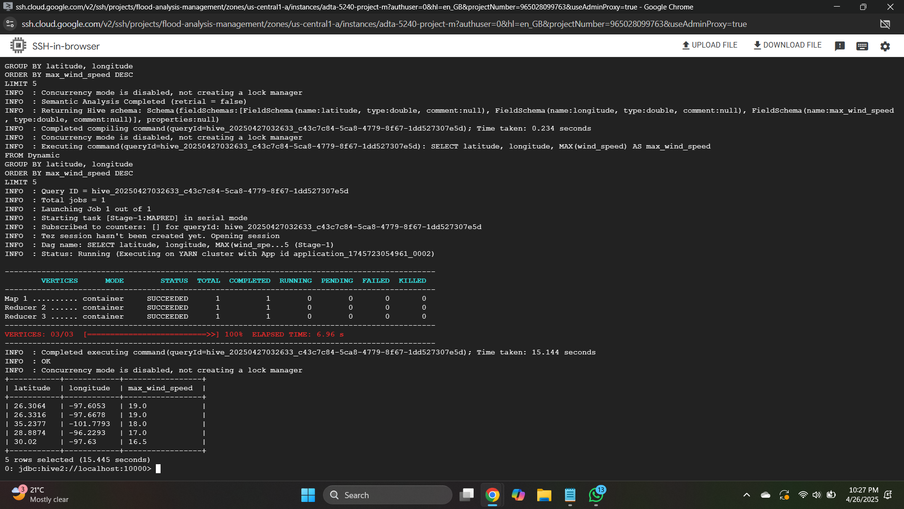

**Screenshot: Hive Outputs- Highest Wind Speeds by Geographic Location (Rohith Singh Thakur)**

**QUERY 2:**

SELECT date, AVG(temp) AS avg_temperature

FROM Dynamic

GROUP BY date

ORDER BY date;

**Query 2: 15.11s**

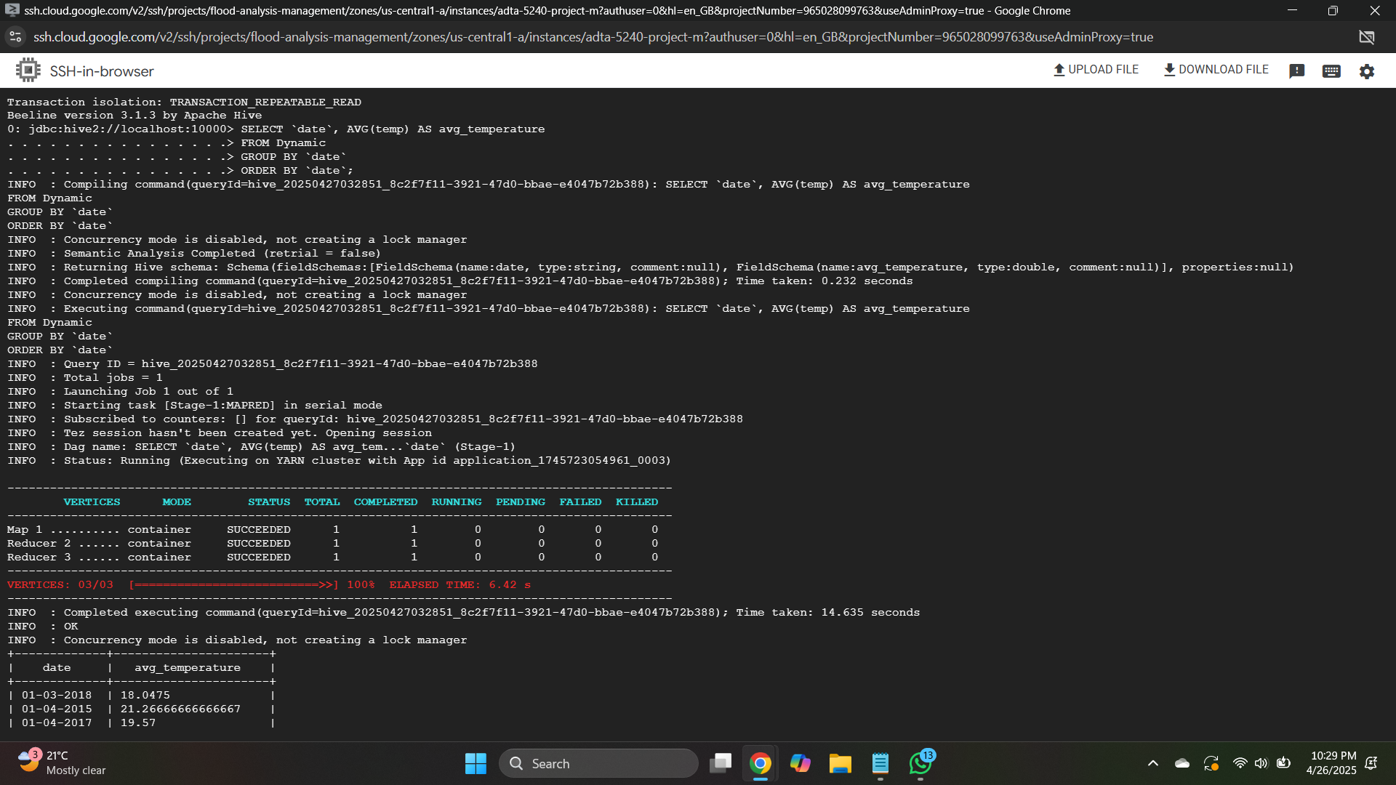**Screenshot: Hive Outputs: Daily Average Temperature Trends from Dynamic Weather (Usha Aavula)**

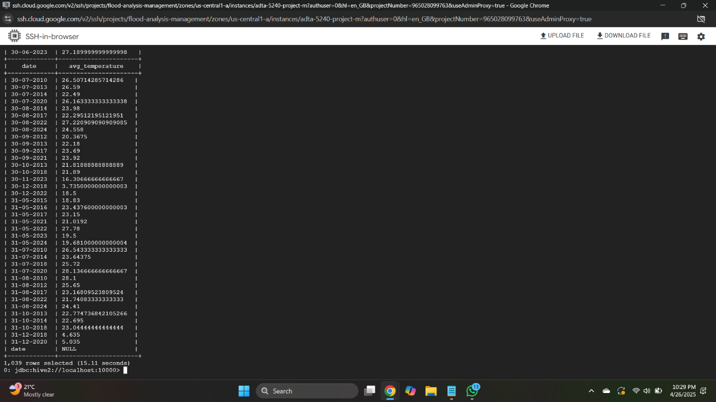

**Screenshot owner: Usha Aavula**

**SPARK Query Outputs**

**Query 1: 1.722s**

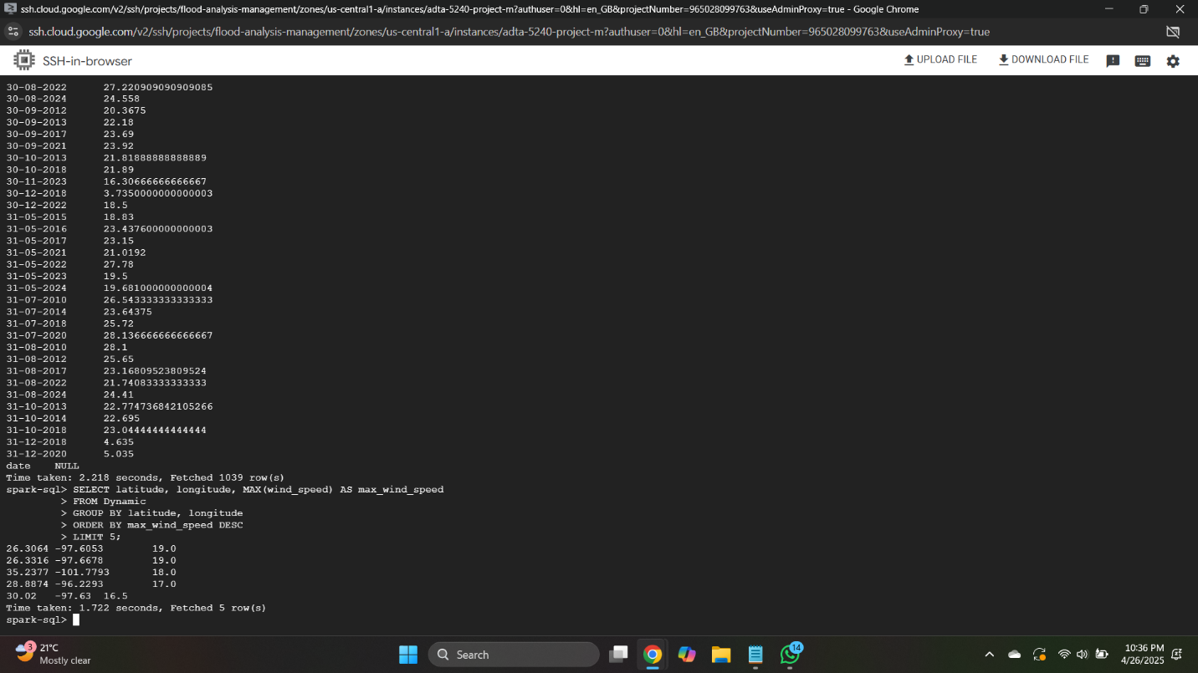

**Screenshot: Spark Output: Highest Wind Speeds by Geographic Location (Rohith Singh Thakur)**

**Query 2: 2.218s**

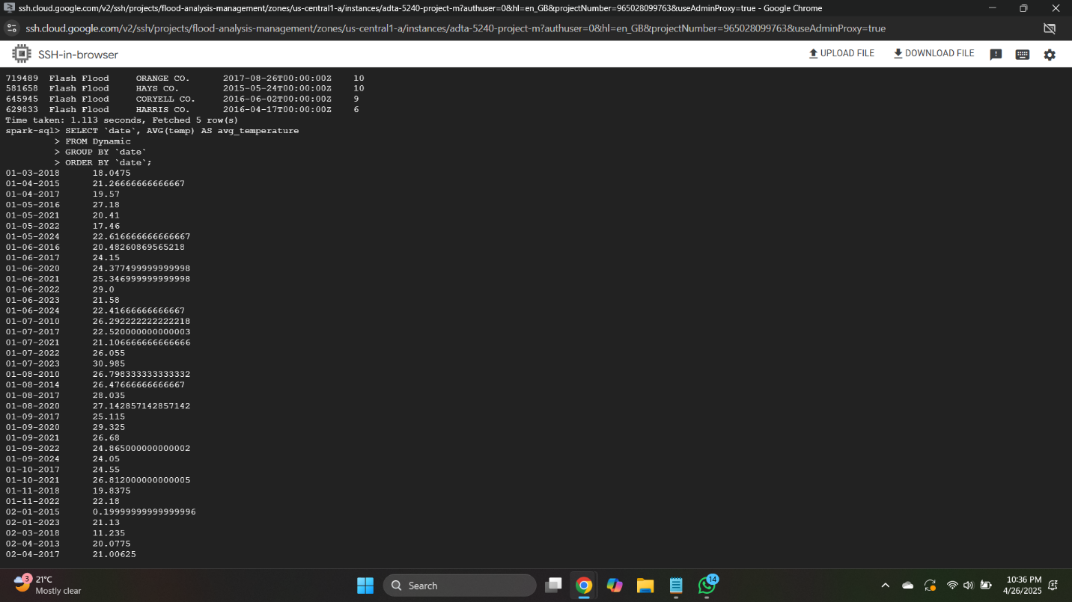

**Screenshot: Spark Output: Daily Average Temperature Trends from Dynamic Weather (Rohith Singh Thakur)**

**Comparison Between Hive and Spark Query Outputs**

**Table:** Comparison of the time taken to run the queries on Hive and Spark

|  | **Hive (seconds)** | **Spark (seconds)** |
| --- | --- | --- |
| **Query 1 (Static Data)** | 32.525 | 11.302 |
| **Query 2 (Static Data)** | 7.285 | 1.113 |
| **Query 1 (Streaming Data)** | 15.445 | 1.722 |
| **Query 2 (Streaming Data)** | 15.11 | 2.218 |

**Observation from the above table:**

From our comparison, Spark performed faster query execution for both static data as well as streaming data, completing tasks much faster compared to Hive. Spark's faster execution makes it the first option for any project for which query execution speed is of utmost importance. As long as Spark possesses a clear performance advantage, it makes sense to select Spark even if it incurs additional computing cost.

But where the Spark-Hive latency is negligible, Hive is a suitable alternative, especially where cost is a factor. Then the sacrifice of speed is overwhelmed by the enormous cost-benefit, and Hive is a more appealing option for nonprofit initiatives such as the Village Resilience Initiative.

For the Village Resilience Initiative, where budget effectiveness matters and minor delays in query execution won't jeopardize the project's overall goals, we're going with Hive. It provides sufficient performance for the purposes of analytics while significantly reducing costs, a consideration for a nonprofit. So, Hive provides the right performance for cost for the project as currently sized.

**BONUS Implementation**

**Data Visualization and Interpretation**

We used Looker Studio to make our BigQuery results into easy-to-interpret interactive visualizations. Because we were able to join BigQuery query results natively within Looker Studio, we were able to make plots and tables dynamically without having to download the results and do the analysis manually. Looker Studio gave us a means of getting our key results structured and graphically represented into professional easy-to-understand form, flood trends as well as the levels of risk over Texas being easy to detect.

1. **Query 1 (Static Data)**

**County-wise Property Damage**

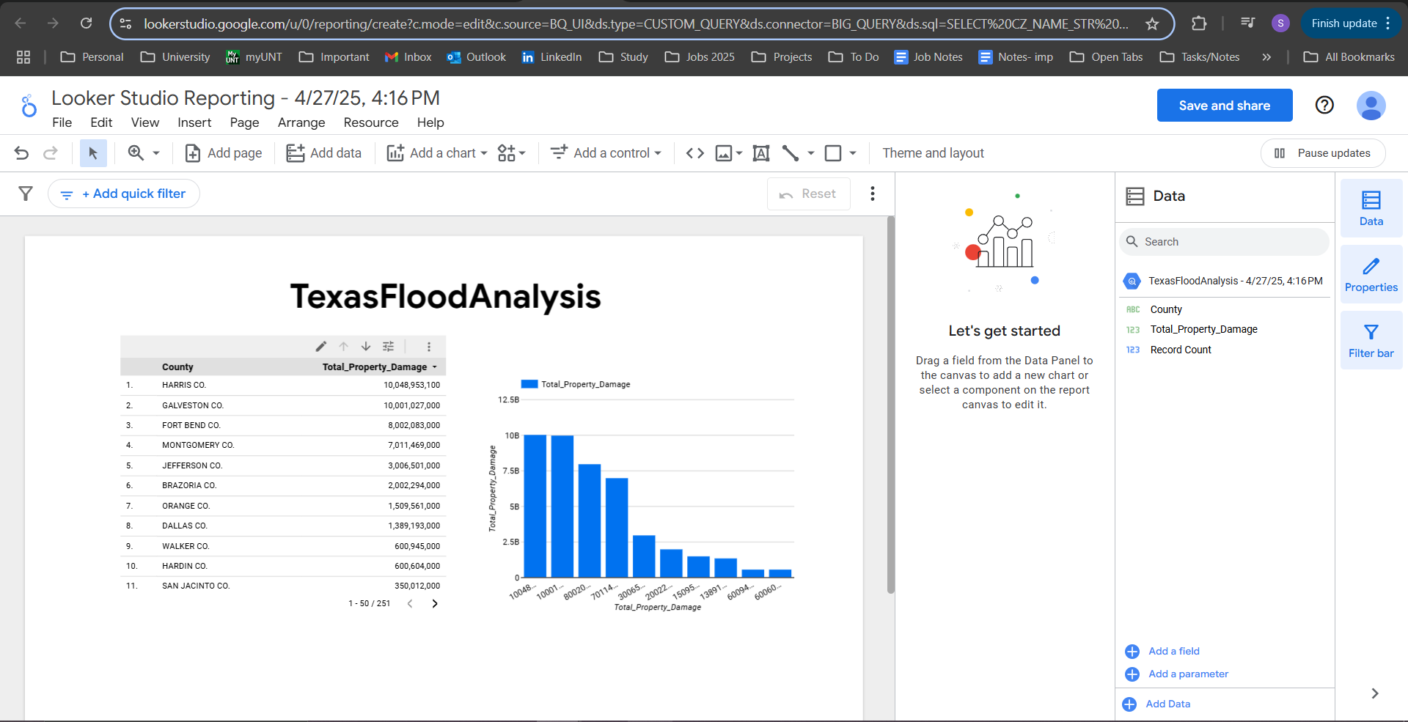

**Screenshot:** Top Texas Counties by Total Flood Property Damage (Sparsha)

**Interpretation of the above visualization:** The table and bar chart show the total property damage due to flood events for various counties of Texas. From the graphical representation, it can be seen that the maximum damages were faced by Harris County and Galveston County, with both of them experiencing over $10 billion damages. Other counties also faced high damages, like Fort Bend and Montgomery, but to a relatively lower degree. This data pinpoints some of the risk zone areas where flood resilient planning along with the deployment of resources needs to be focused.

1. **Query 2 (Static Data)**

**Deadliest Flood Events by Deaths**

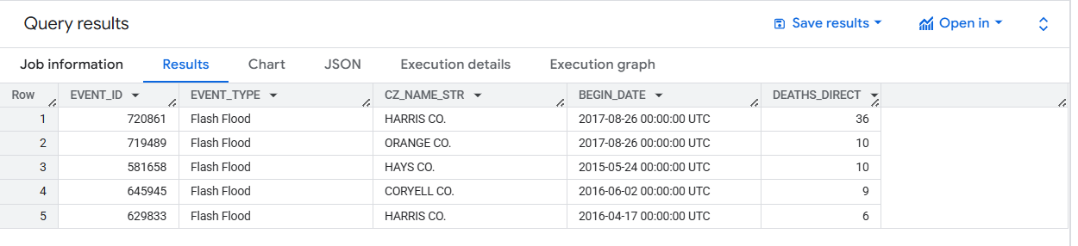

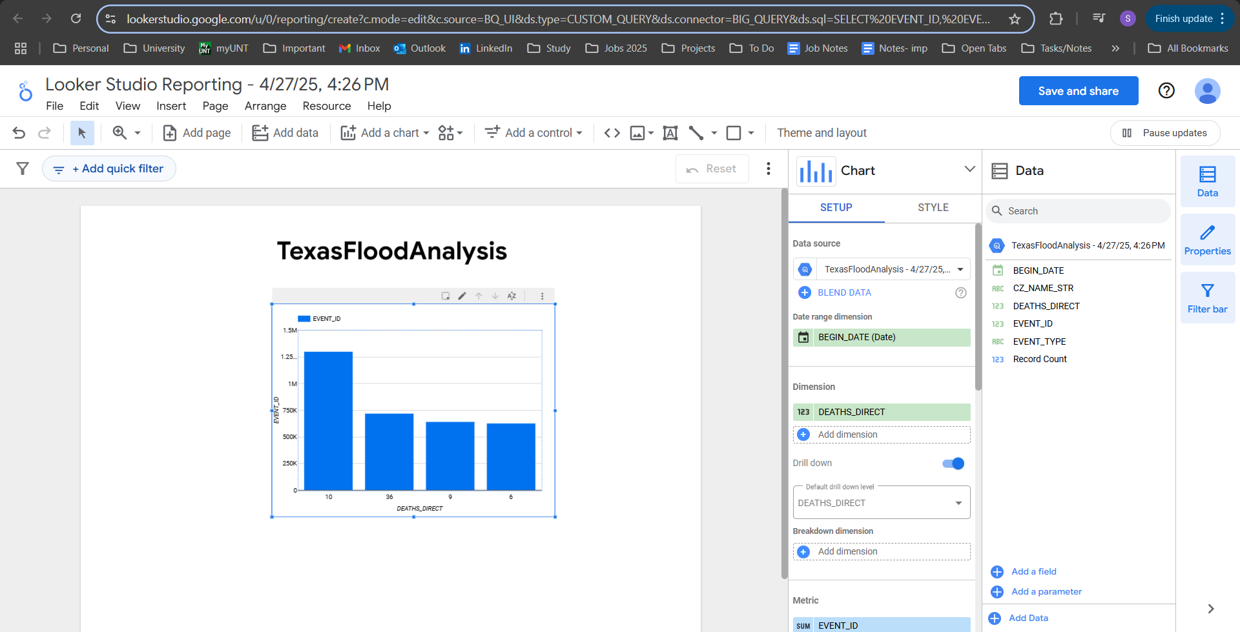

**Screenshot:** Top Deadliest Flood Events in Texas (Based on Direct Deaths). **(** Kaushik)

**Interpretation of the above visualization:** The chart display the top five deadliest Texas flood incidents according to direct fatalities. The most lethal was the event of August 26, 2017, that occurred within the county of Harris with a direct fatality of 36 people. It is a very striking feature compared to other incidents. Other incidents with a direct fatality of 10 people or less are incidents of Orange County, Hays County, and Coryell County. This graph confirms the fact that while most of the incidents had relatively fewer fatalities, there were a number of incidents with huge human impacts, which implies the sheer need for preparedness for emergency in vulnerable counties.

1. **Query 3 (Static Data)**

**Annual Flood Event Counts**

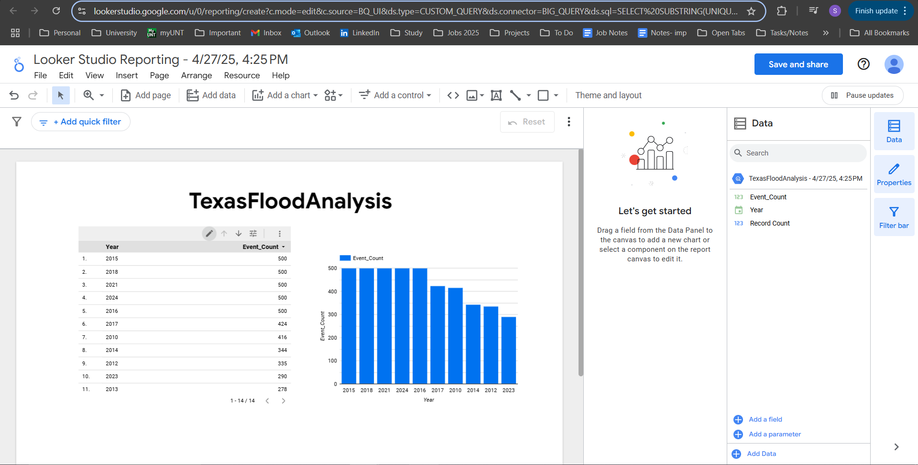

**Screenshot:** Annual Flood Event Trends in Texas (2010–2024). (Sparsha)

**Interpretation of the above visualization:** The graph plots statistics of the occurrence of flooding incidents annually from 2010 to 2024 in Texas. Based on the graph, 2015, 2018, 2021, 2024, and 2016 were the most frequent with about 500 occurrences. Years 2023 and 2022 have lower occurrences. All trends can assist in identifying the duration when there are increased chances of floods happening and can be applied for disaster preparedness, budgeting as well as risk reduction measures.

1. **Query 1 (Streaming Data)**

**Average Daily Temperature Trends (Dynamic Data)**

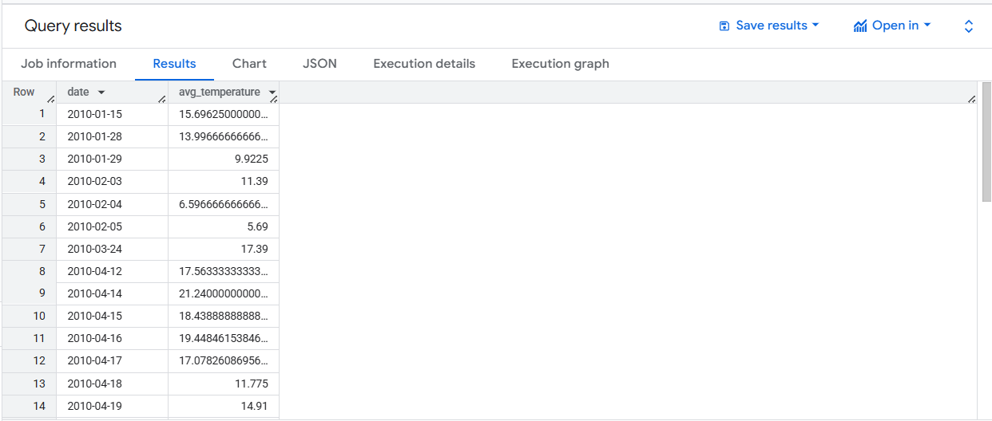

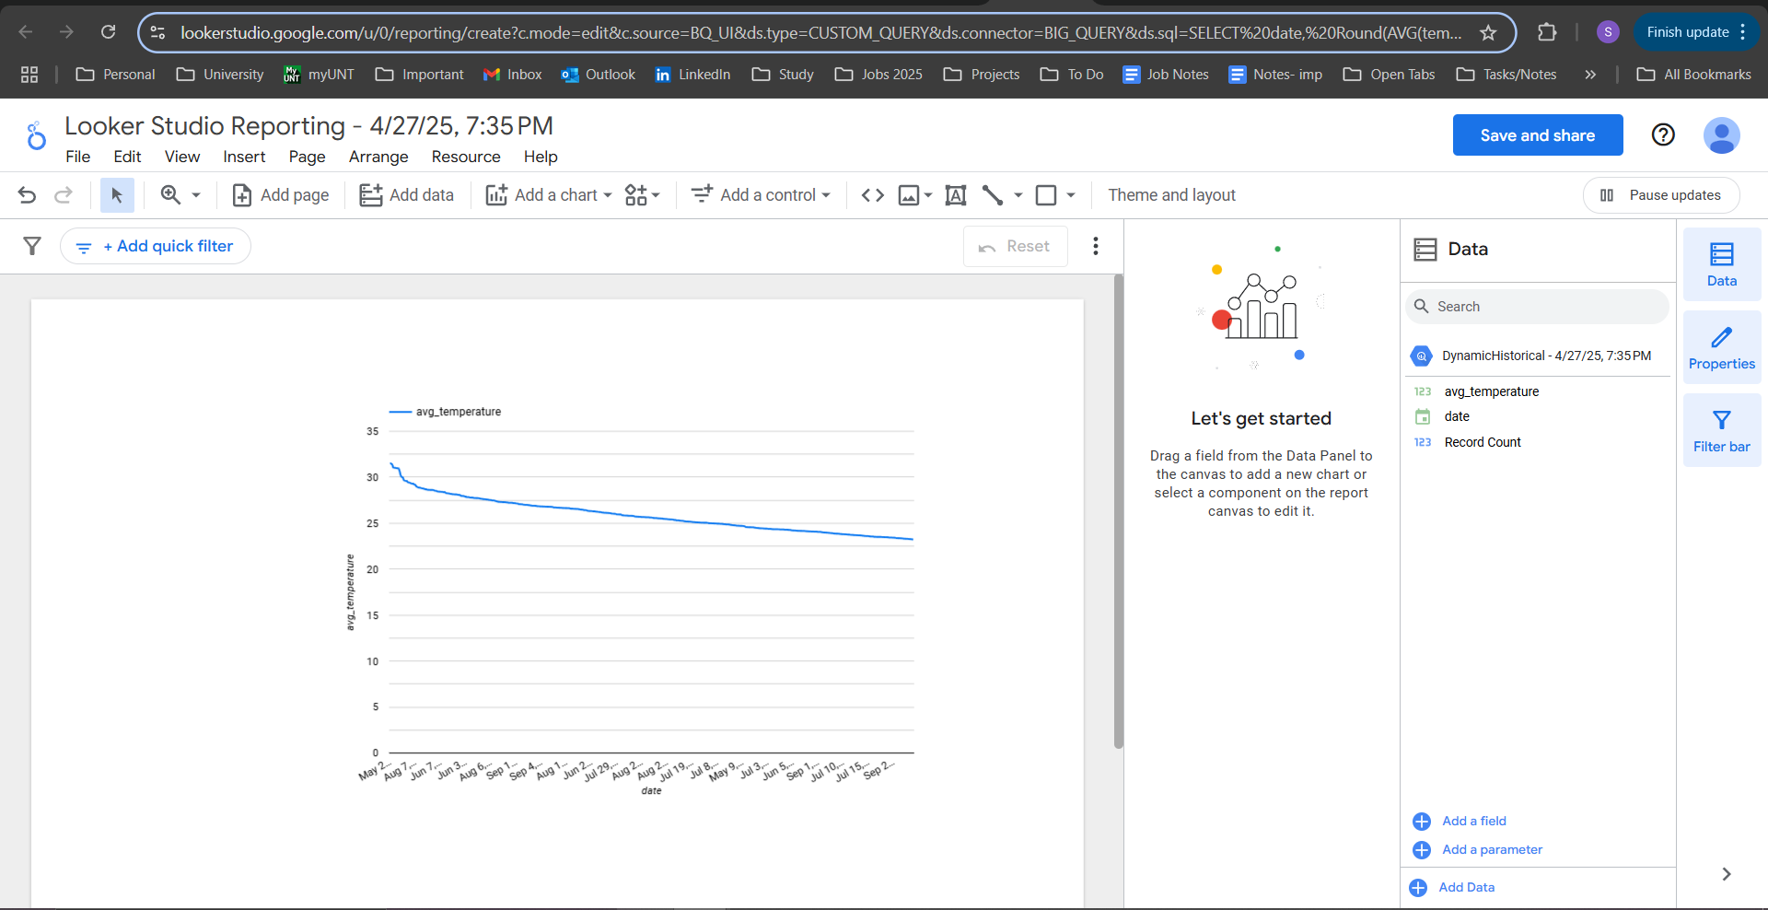

**Screenshot:** Average Daily Temperature Trends (Sparsha).

**Interpretation of the above visualization:** The daily average temperatures obtained dynamically over time are represented by the line graph. It's very crucial to monitor trends of the daily temperatures as the changes may impact atmospheric pressure regimes as well as storm patterns and ultimately flood hazards. While the temperature trend indicates a very stable and steadily declining trend, live monitoring of the environmental condition enables the identification of the initial indicators of the likelihood of extreme weather conditions. With the introduction of dynamic temperature content, the Village Resilience Initiative can monitor the changes likely leading to flood occurrences and plan ahead for necessary measures.

1. **Query 2 (Streaming Data)**

**Top Locations by Maximum Wind Speed (Dynamic Data)**

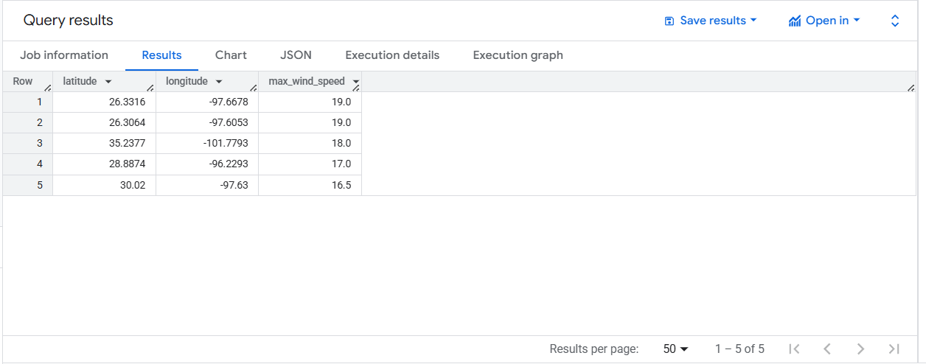

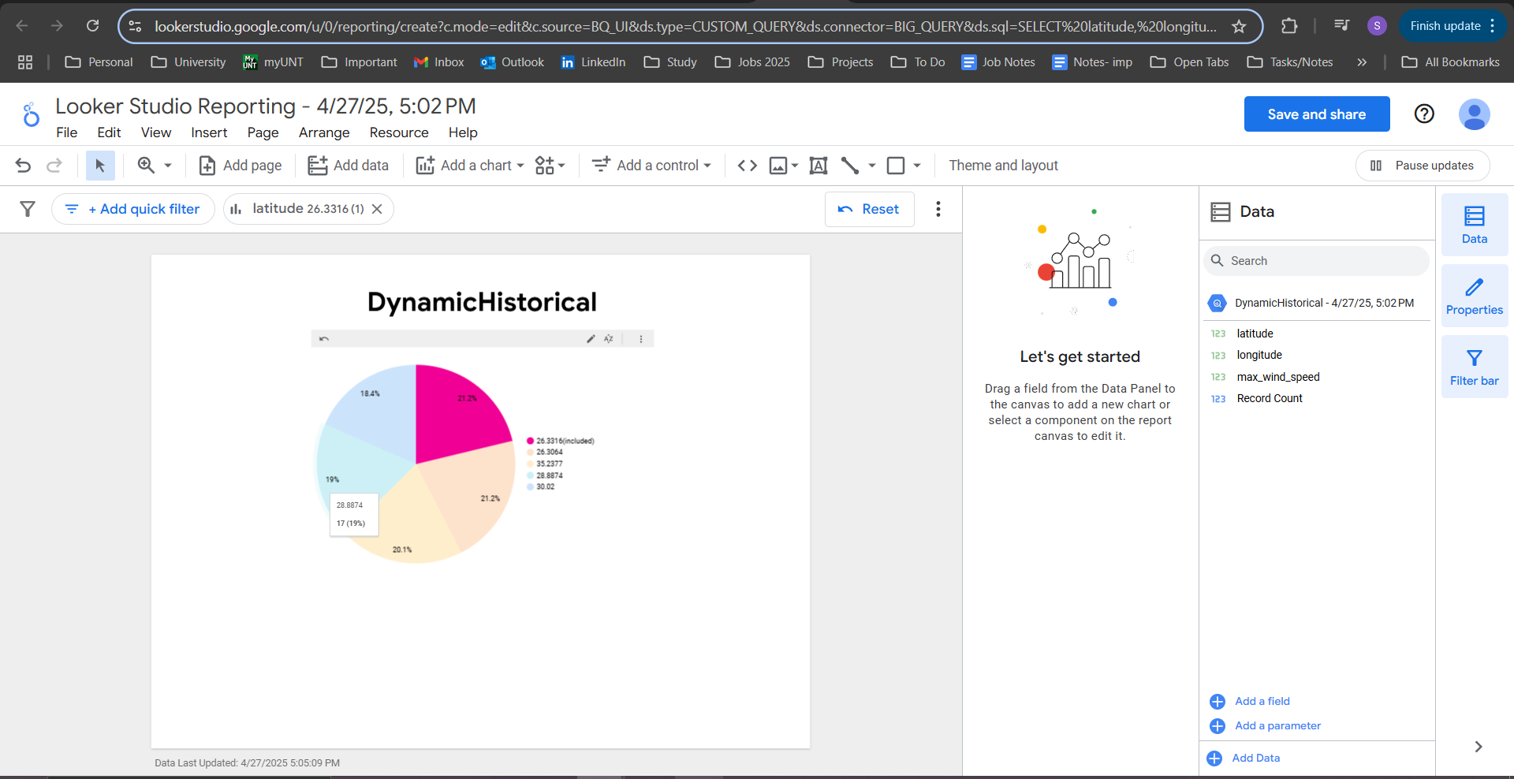

**Screenshot:** Top Locations by Maximum Wind Speed (Dynamic Weather Data)- Based on the Latitude. (Sparsha)

**Interpretation of the above visualization:** The pie chart illustrates the composition of the top five recorded site peak observed wind speeds. Each slice of pie corresponds to a specific site (as listed by latitude) and its respective percentage contribution to peak recorded wind speeds within the data set. Sites of latitude 26.3316° as well as 26.3064° have a slightly higher percentage of peak wind occurrence compared to the rest. Because peak wind speeds have the ability to exacerbate the effects of flood occurrences through increased rainfall intensity, increased surges, as well as structural damage, identification of risk-prone sites is of great significance to effective preparation for as well as mitigation of floods.

**Meeting Notes**

**Day 1: April 15th, 2025**Start Time: 1:00 PM  
End Time: 2:00 PM  
Note-taker: TBD  
Attendees: Kaushik, Arjun, Rohith, Usha, Sparsha, Anusha

**Meeting Notes:**

* We first discussed the overall goal of our project and what we expected out of it.
* We then discussed what datasets we could choose for our project.
* Decided to focus on Texas flood data for static data.
* Explored options for dynamic data sources like OpenWeatherMap and Open-Elevation APIs.
* We also discussed how we would split all the tasks among ourselves.
* Outlined initial steps for data generation and collection.
* Decided to create a new project on Google Cloud Platform (GCP).

**Decisions Made:**

* Finalize static dataset from NOAA Storm Events Database (Texas-specific).
* Confirm OpenWeatherMap API for dynamic weather data collection.
* Include Open-Elevation API to collect elevation information.
* Create a new GCP project for data storage and cloud resource management.
* Start dataset generation and download processes.
* Split tasks among group members.

| Action Item # | Description | Owner | Due Date | Status |
| --- | --- | --- | --- | --- |
| 1 | Finalize Datasets (1 static and 1 streaming) | Kaushik, Arjun, Rohith, Usha, Sparsha, Anusha | April 16th | Completed |
| 2 | Research and finalize dynamic data APIs | Kaushik, Arjun, Rohith, Usha, Sparsha, Anusha | April 16th | Completed |
| 3 | Create new GCP project for the team's work | Arjun | April 16th | Completed |
| 4 | Set up GCP storage buckets for datasets | Arjun | April 17th | Completed |
| 5 | Download the initial static dataset records | Arjun/Kaushik | April 18th | Completed |
| 6 | Test API data pull for a few events (dynamic) | Sparsha | April 20th | Completed |

—------------------------------------------------------------------------------------------------------------------

**Day 2: April 22nd, 2025**

Start Time: 12:00 PM  
End Time: 2:00 PM  
Note-taker: TBD  
Attendees: Kaushik, Arjun, Rohith, Usha, Sparsha, Anusha

**Meeting Notes:**

* Reviewed the collected static flood data from NOAA.
* Successfully pulled initial dynamic weather and elevation data.
* Discussed cleaning requirements like checking missing values, etc.
* Assigned OpenRefine tasks for cleaning and formatting datasets.
* Planned next steps for loading data into BigQuery.

**Decisions Made:**

* Use OpenRefine for static data cleaning.
* Finalize dynamic data fields: temperature, rain, wind speed, elevation.
* Load cleaned static data into BigQuery.
* Prepare dynamic data for integration with static records.

| Action Item # | Description | Owner | Due Date | Status |
| --- | --- | --- | --- | --- |
| 1 | Clean static dataset using OpenRefine | Arjun | April 24th | Completed |
| 2 | Clean dynamic data and format timestamps | Sparsha/Kaushik | April 24th | Completed |
| 3 | Load datasets into BigQuery | Rohith | April 24th | Completed |
| 4 | Validate datasets for missing/incorrect values | Arjun/Sparsha/Kaushik | April 24th | Completed |

—------------------------------------------------------------------------------------------------------------------

**Day 3: April 25th, 2025**

Start Time: 10:00 AM  
End Time: 1:00 PM  
Note-taker: TBD  
Attendees: Kaushik, Arjun, Rohith, Usha, Sparsha, Anusha

**Meeting Notes:**

* Completed cleaning of static and dynamic datasets.
* Successfully enriched the static dataset with data from the streaming source
* Discussed designing queries in BigQuery, Hive, and Spark.
* Started writing queries in BigQuery.
* Planned to create corresponding Hive and Spark queries for cross-validation.

**Decisions Made:**

* Finalize query designs for property damage, fatalities, and event counts.
* Write queries for weather and wind speed analysis.
* Implement Hive queries using Dataproc cluster.
* Implement Spark queries for comparison.
* Capture screenshots of query executions for documentation.

**Action Items:**

| Action Item # | Description | Owner | Due Date | Status |
| --- | --- | --- | --- | --- |
| 1 | BigQuery queries | Rohith | April 26th | Completed |
| 2 | Implement Hive queries on Dataproc | Rohith | April 26th | Completed |
| 3 | Implement Spark queries on Dataproc | Usha | April 26th | Completed |
| 4 | Take screenshots of query results | Rohith/Usha | April 26th | Completed |

—------------------------------------------------------------------------------------------------------------------

**Day 4: April 26th, 2025**

Start Time: 10:00 AM  
End Time: 1:00 PM  
Note-taker: TBD  
Attendees: Kaushik, Arjun, Rohith, Usha, Sparsha, Anusha

**Meeting Notes:**

* Decided to focus on finalizing the visualization and interpretation phase of the project.
* Selected Looker Studio as the tool for building the charts.
* We decided on created visuals for property damage by county, flood event trends, and maximum wind speeds.
* Also, decided on interpreting the visual outputs to highlight key flood risk patterns.
* We also started working on the final project document and presentation slides.

**Decisions Made:**

* Finalize visualization and interpretation work for the project.
* Use Looker Studio as the primary tool for building all dashboards and charts.
* Create visuals focused on property damage by county, flood event trends, and maximum wind speeds.
* Highlight key risk areas through interpretation of visualization results.
* Begin drafting the final project document and PowerPoint presentation.

**Action Items:**

| Action Item # | Description | Owner | Due Date | Status |
| --- | --- | --- | --- | --- |
| 1 | Complete final visualizations in Looker Studio | Sparsha/Kaushik | April 27th | Completed |
| 2 | Interpret and summarize key insights from visuals | Anusha | April 27th | Completed |
| 3 | Start drafting the final project document | Sparsha | April 27th | Completed |
| 4 | Begin creating the final presentation slides | Anusha | April 27th | Completed |

**—------------------------------------------------------------------------------------------**

**Final Meeting: April 28th, 2025**

Start Time: 10:00 AM  
End Time: 1:00 PM  
Note-taker: TBD  
Attendees: Kaushik, Arjun, Rohith, Usha, Sparsha, Anusha

**Meeting Notes:**

* Completed all project tasks including data processing, visualization, interpretation, and documentation.
* Finalized the project report and presentation slides.
* Prepared and rehearsed for the final project presentation

**Decisions Made:**

* Confirm that all datasets, queries, and visualizations are complete.
* Finalize the Word document and PowerPoint submission.
* Assign final speaking roles for presentation.
* Conduct a final review of project deliverables.
* Submit the project before the presentation.

| Action Item # | Description | Owner | Due Date | Status |
| --- | --- | --- | --- | --- |
| 1 | Finalize Word project document | All Team members | April 28th | Completed |
| 2 | Finalize PowerPoint presentation slides | All Team members | April 28th | Completed |
| 3 | Rehearse group presentation | All Team members | April 28th | Completed |
| 4 | Prepare for Q&A during the presentation | All Team members | April 28th | Completed |

**Data Life Cycle Assignment Table**

| **Phase** | **Owner** | **Status** |
| --- | --- | --- |
| Data Generation | Kaushik/Sparsha | Completed |
| Data Collection | Arjun/Kaushik/Sparsha | Completed |
| Data Processing | Arjun/Kaushik/Sparsha | Completed |
| Data Storage | Arjun | Completed |
| Data Management | Rohith/Usha | Completed |
| Data Analysis | Rohith/Usha | Completed |
| Data Visualization | Kaushik/Sparsha | Completed |
| Data Interpretation | Anusha | Completed |

**Conclusion**

In this project, we managed to create a cloud-based data platform by which the Village Resilience Initiative is able to obtain insights into, and also respond to, the threat of disaster-level flooding in rural villages in a more effective manner. By consuming, processing, and also enriching blended static and also dynamic data sources, we managed to achieve a unified and also updated perspective regarding Texas encompassing flood risks.. Using software applications such as BigQuery, Hive, Spark, OpenRefine, and Looker Studio, we were able to maintain data quality, scalability, focused analysis, and effective visualization at all data life cycle stages.

These analytics and visualizations provide actionable insight for disaster preparedness priority setting, investment decisions for infrastructure, and expedited decision-making support for emergency response. It can be supplemented with real-time alerting and predictive modeling capabilities in the future to empower the nonprofit to support the vulnerable with data-based programming.

For the future, several possible solutions can further improve this effort:

* Flood Vulnerability Mapping to determine high-risk areas.
* Real-Time Community Notifications for faster neighborhood alerts.
* Risk Analysis of Infrastructure to Secure Key Installations.
* Anticipatory resource allocation towards enhancing emergency preparedness.
* Seasonal flood forecast to identify peak flood periods.
* Real-time and historical data predictive modeling of disasters for warning.

Together, these next steps can move Village Resilience Initiative work from a response to disasters to proactive community protection, a safer, more resilient future for vulnerable citizens.

**References**

[1] Google Cloud. (n.d.). *BigQuery Documentation*. Google Cloud. Retrieved April 27, 2025, from https://cloud.google.com/bigquery/docs

[2] Apache Software Foundation. (n.d.). *Apache Hive Documentation*. Retrieved April 27, 2025, from<https://hive.apache.org/>

[3] Apache Software Foundation. (n.d.). *Apache Spark Documentation*. Retrieved April 27, 2025, from<https://spark.apache.org/docs/latest/>

[4] OpenRefine. (n.d.). *OpenRefine: A free, open source, powerful tool for working with messy data*. Retrieved April 27, 2025, from<https://openrefine.org/>

[5] Google Cloud. (n.d.). *Looker Studio Help*. Retrieved April 27, 2025, from https://support.google.com/looker-studio/

[6] NOAA National Centers for Environmental Information. (n.d.). *Storm Events Database*. Retrieved April 27, 2025, from<https://www.ncdc.noaa.gov/stormevents/>

[7] OpenWeather. (n.d.). *OpenWeatherMap API Documentation*. Retrieved April 27, 2025, from https://openweathermap.org/api

[8] Open-Elevation. (n.d.). *Open-Elevation API*. Retrieved April 27, 2025, from<https://open-elevation.com/>